

CAP, BASE, SOLID, KISS, What do these acronyms mean?  
.  
.  
The diagram below explains the common acronyms in system designs.  
  
🔹 CAP  
CAP theorem states that any distributed data store can only provide two of the following three guarantees:  
1. Consistency - Every read receives the most recent write or an error.  
2. Availability - Every request receives a response.  
3. Partition tolerance - The system continues to operate in network faults.  
  
However, this theorem was criticized for being too narrow for distributed systems, and we shouldn’t use it to categorize the databases. Network faults are guaranteed to happen in distributed systems, and we must deal with this in any distributed systems.  
  
You can read more on this in “Please stop calling databases CP or AP” by Martin Kleppmann.  
  
🔹 BASE  
The ACID (Atomicity-Consistency-Isolation-Durability) model used in relational databases is too strict for NoSQL databases. The BASE principle offers more flexibility, choosing availability over consistency. It states that the states will eventually be consistent.  
  
🔹 SOLID  
SOLID principle is quite famous in OOP. There are 5 components to it.  
  
1. SRP (Single Responsibility Principle)  
Each unit of code should have one responsibility.  
  
2. OCP (Open Close Principle)  
Units of code should be open for extension but closed for modification.  
  
3. LSP (Liskov Substitution Principle)  
A subclass should be able to be substituted by its base class.  
  
4. ISP (Interface Segregation Principle)  
Expose multiple interfaces with specific responsibilities.  
  
5. DIP (Dependency Inversion Principle)  
Use abstractions to decouple dependencies in the system.  
  
🔹 KISS  
"Keep it simple, stupid!" is a design principle first noted by the U.S. Navy in 1960. It states that most systems work best if they are kept simple.  
  
Over to you: Have you invented any acronyms in your career?

𝐇𝐨𝐰 𝐭𝐨 𝐫𝐞𝐝𝐮𝐜𝐞 𝐭𝐡𝐞 𝐥𝐚𝐭𝐞𝐧𝐜𝐲 𝐢𝐧 𝐚𝐧𝐲 𝐬𝐨𝐟𝐭𝐰𝐚𝐫𝐞 𝐬𝐲𝐬𝐭𝐞𝐦?  
  
𝟏. 𝐂𝐚𝐜𝐡𝐢𝐧𝐠  
Temporarily storing frequently accessed data in memory to reduce access time.  
  
How It Helps:  
Data Retrieval: Fetching data from a cache (e.g., Redis, Memcached) is significantly faster than querying a database.  
Content Delivery: Caching static assets (like images, CSS, JS) reduces the need to retrieve them from the origin server repeatedly.  
  
𝟐. 𝐋𝐨𝐚𝐝 𝐁𝐚𝐥𝐚𝐧𝐜𝐢𝐧𝐠  
Distributing incoming network traffic across multiple servers to ensure no single server becomes a bottleneck.  
  
How It Helps:  
Resource Utilization: Balances the load to prevent any single server from becoming overwhelmed, which can slow down response times.  
Redundancy: Provides failover capabilities, ensuring requests are handled promptly even if some servers are down.  
  
𝟑. 𝐀𝐬𝐲𝐧𝐜𝐡𝐫𝐨𝐧𝐨𝐮𝐬 𝐏𝐫𝐨𝐜𝐞𝐬𝐬𝐢𝐧𝐠  
Handling tasks in the background without blocking the main execution thread, allowing the system to continue processing other requests.  
  
How It Helps:  
Non-blocking Operations: Users don't have to wait for long-running tasks (like sending emails or processing images) to complete.  
  
𝟒. 𝐃𝐚𝐭𝐚 𝐏𝐚𝐫𝐭𝐢𝐭𝐢𝐨𝐧𝐢𝐧𝐠 (𝐒𝐡𝐚𝐫𝐝𝐢𝐧𝐠)  
Dividing a database into smaller, more manageable pieces (shards) that can be distributed across multiple servers.  
  
How It Helps:  
Parallelism: Queries can be executed in parallel across shards, reducing the time to retrieve data.  
Scalability: Distributes the load, preventing any single database instance from becoming a bottleneck.  
  
𝟓. 𝐂𝐨𝐧𝐭𝐞𝐧𝐭 𝐃𝐞𝐥𝐢𝐯𝐞𝐫𝐲 𝐍𝐞𝐭𝐰𝐨𝐫𝐤𝐬 (𝐂𝐃𝐍𝐬)  
Distributed networks of servers that deliver web content based on the geographic location of the user.  
  
How It Helps:  
Proximity: Serves content from servers closest to the user, reducing the physical distance data must travel.  
Caching: Caches static and dynamic content to speed up delivery.  
  
𝟔. 𝐃𝐚𝐭𝐚𝐛𝐚𝐬𝐞 𝐎𝐩𝐭𝐢𝐦𝐢𝐳𝐚𝐭𝐢𝐨𝐧  
Tuning databases to perform queries more efficiently through indexing, query optimization, and proper schema design.  
  
How It Helps:  
Indexing: Speeds up data retrieval by allowing the database to find records without scanning entire tables.  
  
𝟕. 𝐌𝐢𝐧𝐢𝐦𝐢𝐳𝐢𝐧𝐠 𝐍𝐞𝐭𝐰𝐨𝐫𝐤 𝐇𝐨𝐩𝐬  
Reducing the number of intermediary steps data must pass through and choosing efficient communication protocols.  
  
How It Helps:  
Fewer Hops: Each network hop introduces additional latency; minimizing them speeds up data transmission.  
  
𝟗. 𝐏𝐫𝐞𝐟𝐞𝐭𝐜𝐡𝐢𝐧𝐠 𝐚𝐧𝐝 𝐏𝐫𝐞𝐝𝐢𝐜𝐭𝐢𝐯𝐞 𝐋𝐨𝐚𝐝𝐢𝐧𝐠  
Anticipating future data requests and loading them in advance.  
  
How It Helps:  
Reduced Wait Times: Data is already available when requested, eliminating retrieval delays.  
Smoother User Experience: Especially effective in applications with predictable access patterns.  


**24 principles that can help you navigate System Design Interviews:**  
✅ If you need to scale an individual component, stick with Vertical Scaling first. Then, look at Horizontal Scaling when needed  
  
✅ To deal with traffic spikes, evaluate the use of Autoscaling for Dynamic Resource Allocation  
  
✅ If the system requires High Availability with Performance, consider using a Load Balancer  
  
✅ If you’re building a read-heavy system, it’s a good idea to use a Cache  
  
✅ Listen to the system requirements properly and note them down if needed  
  
✅ To reduce the latency of static assets, consider using a CDN  
  
✅ If you want to improve the database query performance, focus on the right indexes  
  
✅ To scale the read requests to your database, consider Database Replication  
  
✅ To scale write requests, consider Database Sharding  
  
✅ Clarify your assumptions before jumping into the solution  
  
✅ For global distribution of data, use a CDN  
  
✅ If you want to store complex data such as videos, images and files, go for an Object Storage  
  
✅ To manage the load on the server and prevent denial-of-service attacks, use Rate Limiting  
  
✅ In order to remove a Single Point of Failure, implement Redundancy and Isolation  
  
✅ Clarify about the Non-Functional Requirements as well and take them into account  
  
✅ To improve the Fault Tolerance and Durability of your data, consider Data Replication techniques  
  
✅ If the system needs to execute long-running tasks, use Async Processing and Background Processes  
  
✅ To build a loosely coupled system, consider the use of Event-Driven Architecture  
  
✅ If the system needs to store unstructured data, consider NoSQL databases  
  
✅ Keep getting feedback during the discussion rather than waiting till the end  
  
✅ To deal with large amounts of data flowing through the network, use Compression and Pagination techniques  
  
✅ For automated builds and deployments, consider implementing CI/CD pipelines  
  
✅ If you want to achieve independent deployments of various parts of the system, consider microservices architecture  
  
✅ Establish good eye contact with the interviewer and answer the questions confidently.

System Design was HARD.  
  
Learning these concepts made it easier for me:  
  
𝟭. 𝗦𝗰𝗮𝗹𝗮𝗯𝗶𝗹𝗶𝘁𝘆: <https://lnkd.in/dD-GZpVq>  
  
𝟮. 𝗟𝗮𝘁𝗲𝗻𝗰𝘆 𝘃𝘀 𝗧𝗵𝗿𝗼𝘂𝗴𝗵𝗽𝘂𝘁: <https://lnkd.in/dscK9g3E>  
  
𝟯. 𝗖𝗔𝗣 𝗧𝗵𝗲𝗼𝗿𝗲𝗺: <https://lnkd.in/dFpgDSnY>  
  
𝟰. 𝗔𝗖𝗜𝗗 𝗧𝗿𝗮𝗻𝘀𝗮𝗰𝘁𝗶𝗼𝗻𝘀: <https://lnkd.in/dkkmMu_D>  
  
𝟱. 𝗔𝗣𝗜 𝗗𝗲𝘀𝗶𝗴𝗻: <https://lnkd.in/dTgxGa5i>  
  
𝟲. 𝗥𝗮𝘁𝗲 𝗟𝗶𝗺𝗶𝘁𝗶𝗻𝗴: <https://lnkd.in/dY9NqRG9>  
  
𝟳. 𝗦𝘁𝗿𝗼𝗻𝗴 𝘃𝘀 𝗘𝘃𝗲𝗻𝘁𝘂𝗮𝗹 𝗖𝗼𝗻𝘀𝗶𝘀𝘁𝗲𝗻𝗰𝘆: <https://lnkd.in/dQDwa7TQ>  
  
𝟴. 𝗗𝗶𝘀𝘁𝗿𝗶𝗯𝘂𝘁𝗲𝗱 𝗧𝗿𝗮𝗰𝗶𝗻𝗴: <https://lnkd.in/dA-3swq2>  
  
𝟵. 𝗦𝘆𝗻𝗰𝗵𝗿𝗼𝗻𝗼𝘂𝘀 𝘃𝘀. 𝗮𝘀𝘆𝗻𝗰𝗵𝗿𝗼𝗻𝗼𝘂𝘀 𝗰𝗼𝗺𝗺𝘂𝗻𝗶𝗰𝗮𝘁𝗶𝗼𝗻𝘀: <https://lnkd.in/dx2nFDgR>  
  
𝟭𝟬. 𝗕𝗮𝘁𝗰𝗵 𝗣𝗿𝗼𝗰𝗲𝘀𝘀𝗶𝗻𝗴 𝘃𝘀 𝗦𝘁𝗿𝗲𝗮𝗺 𝗣𝗿𝗼𝗰𝗲𝘀𝘀𝗶𝗻𝗴: <https://lnkd.in/dqGFQppV>  
  
𝟭𝟭. 𝗙𝗮𝘂𝗹𝘁 𝗧𝗼𝗹𝗲𝗿𝗮𝗻𝗰𝗲: <https://lnkd.in/dzKWh4ju>

**CAP**

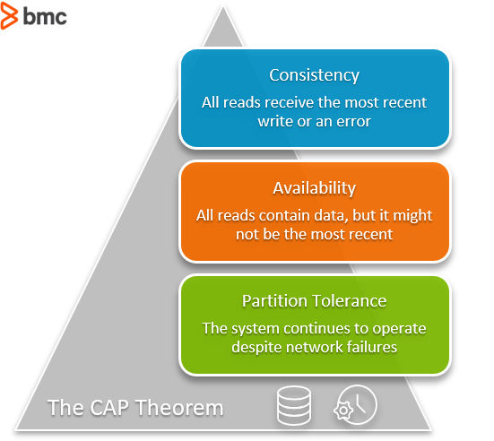

**In the theorem,**[**partition tolerance is a must**](https://codahale.com/you-cant-sacrifice-partition-tolerance/)**. The assumption is that the system operates on a distributed data store so the system, by nature, operates with network partitions. Network failures will happen, so to offer any kind of reliable service, partition tolerance is necessary—the P of CAP.**

**That leaves a decision between the other two, C and A. When a network failure happens, one can choose to guarantee consistency or availability:**

* **High consistency comes at the cost of lower availability.**
* **High availability comes at the cost of lower consistency.**

**Consistency in CAP is different than that of**[**ACID**](https://www.bmc.com/blogs/acid-atomic-consistent-isolated-durable/)**. Consistency in CAP means having the most up-to-date information. (ACID refers to a different database event. In ACID, consistency means any new transaction to the database won’t corrupt the database.)**

**Database options for consistency:**

* **MongoDB**
* **Redis**
* **HBase**

**Database options for availability:**

* [**Cassandra**](https://www.bmc.com/blogs/apache-cassandra-introduction/)
* **DynamoDB**
* **Cosmos DB**

**SCALABILITY**

As a system grows, the performance starts to degrade unless we adapt it to deal with that growth.

Scalability is the property of a system to handle a growing amount of load by adding resources to the system.

A system that can continuously evolve to support a growing amount of work is scalable.

In this article, we will explore different ways a system can grow and common ways to make a system scalable.

How can a System Grow?

A system can grow in several dimensions.

[[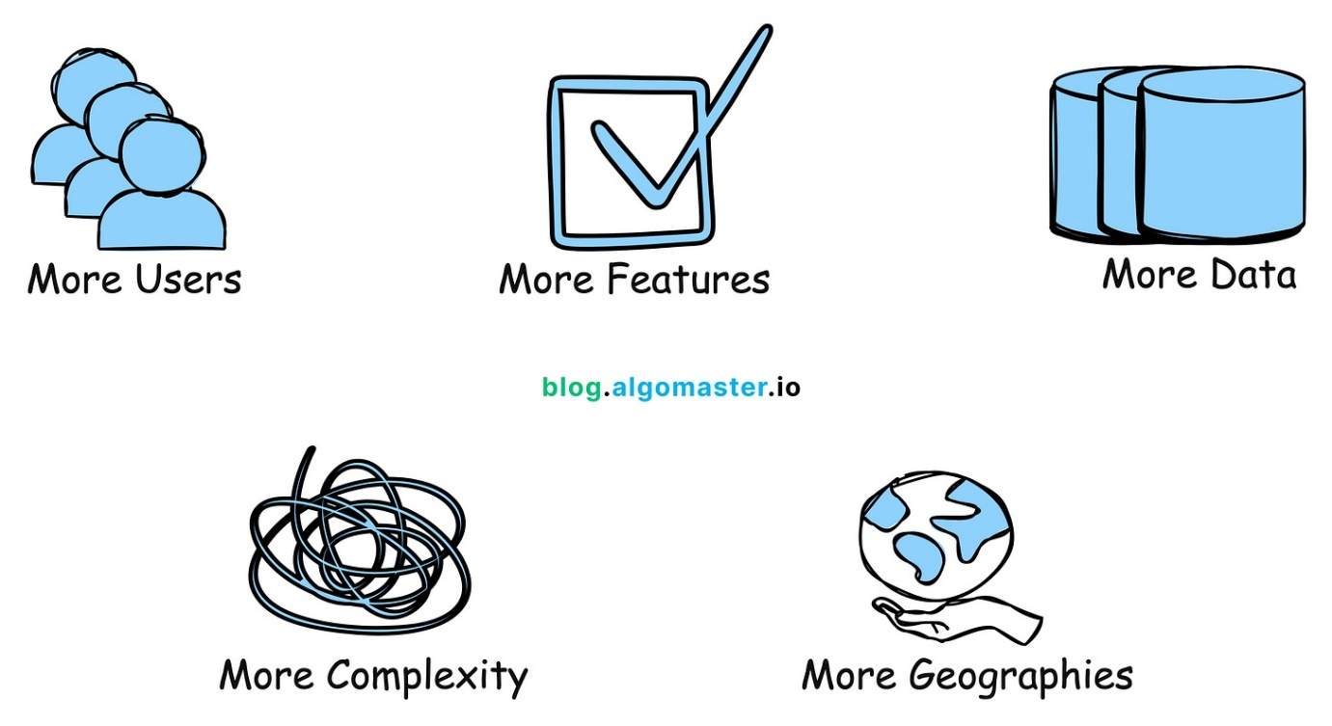](https://substackcdn.com/image/fetch/f_auto,q_auto:good,fl_progressive:steep/https%3A%2F%2Fsubstack-post-media.s3.amazonaws.com%2Fpublic%2Fimages%2Fc0c134bb-21e1-4bf9-8bd2-c03ae1cfbcbf_2020x1106.png)](https://substackcdn.com/image/fetch/f_auto,q_auto:good,fl_progressive:steep/https%3A%2F%2Fsubstack-post-media.s3.amazonaws.com%2Fpublic%2Fimages%2Fc0c134bb-21e1-4bf9-8bd2-c03ae1cfbcbf_2020x1106.png" \t "_blank)

1. Growth in User Base

More users started using the system, leading to increased number of requests.

* Example: A social media platform experiencing a surge in new users.

2. Growth in Features

More features were introduced to expand the system's capabilities.

* Example: An e-commerce website adding support for a new payment method.

3. Growth in Data Volume

Growth in the amount of data the system stores and manages due to user activity or logging.

* Example: A video streaming platform like youtube storing more video content over time.

4. Growth in Complexity

The system's architecture evolves to accommodate new features, scale, or integrations, resulting in additional components and dependencies.

* Example: A system that started as a simple application is broken into smaller, independent systems.

5. Growth in Geographic Reach

The system is expanded to serve users in new regions or countries.

* Example: An e-commerce company launching websites and distribution in new international markets.

How to Scale a System?

Here are 10 common ways to make a system scalable:

1. Vertical Scaling (Scale up)

This means adding more power to your existing machines by upgrading server with more RAM, faster CPUs, or additional storage. It's a good approach for simpler architectures but has limitations in how far you can go.

[[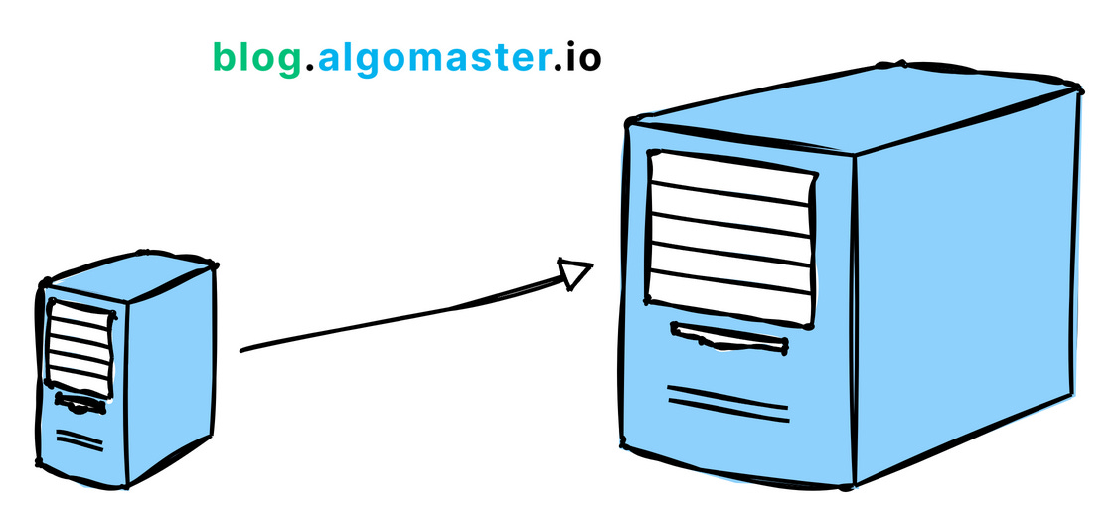](https://substackcdn.com/image/fetch/f_auto,q_auto:good,fl_progressive:steep/https%3A%2F%2Fsubstack-post-media.s3.amazonaws.com%2Fpublic%2Fimages%2F5f329a60-553d-42ba-bd38-3228d8ce894d_1126x530.png)](https://substackcdn.com/image/fetch/f_auto,q_auto:good,fl_progressive:steep/https%3A%2F%2Fsubstack-post-media.s3.amazonaws.com%2Fpublic%2Fimages%2F5f329a60-553d-42ba-bd38-3228d8ce894d_1126x530.png" \t "_blank)

2. Horizontal Scaling (Scale out)

This means adding more machines to your system to spread the workload across multiple servers. It's often considered the most effective way to scale for large systems.

[[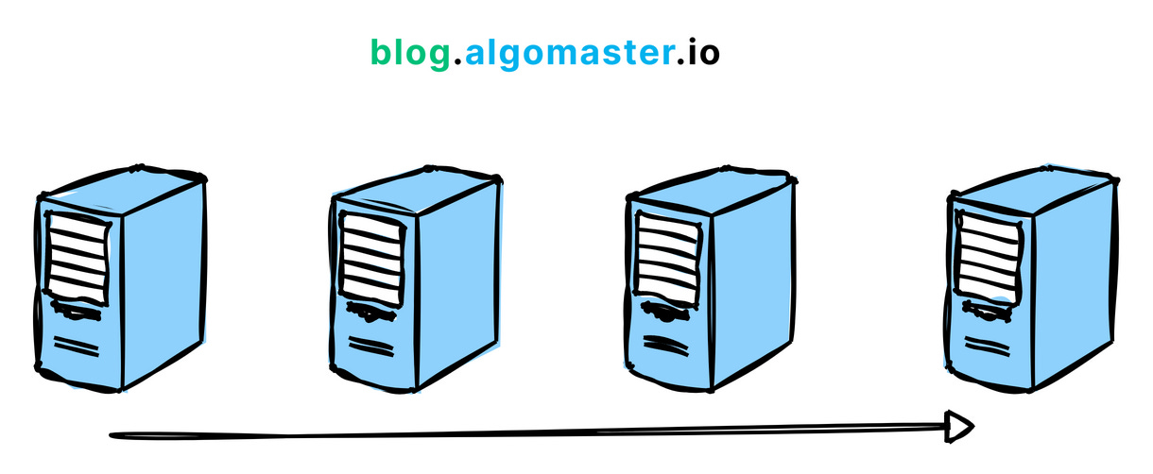](https://substackcdn.com/image/fetch/f_auto,q_auto:good,fl_progressive:steep/https%3A%2F%2Fsubstack-post-media.s3.amazonaws.com%2Fpublic%2Fimages%2F06672b7c-5b2f-420e-8c6a-ef5f6f924c99_1220x502.png)](https://substackcdn.com/image/fetch/f_auto,q_auto:good,fl_progressive:steep/https%3A%2F%2Fsubstack-post-media.s3.amazonaws.com%2Fpublic%2Fimages%2F06672b7c-5b2f-420e-8c6a-ef5f6f924c99_1220x502.png" \t "_blank)

Example: Netflix uses horizontal scaling for its streaming service, adding more servers to their clusters to handle the growing number of users and data traffic.

3. Load Balancing

Load balancing is the process of distributing traffic across multiple servers to ensure no single server becomes overwhelmed.

[[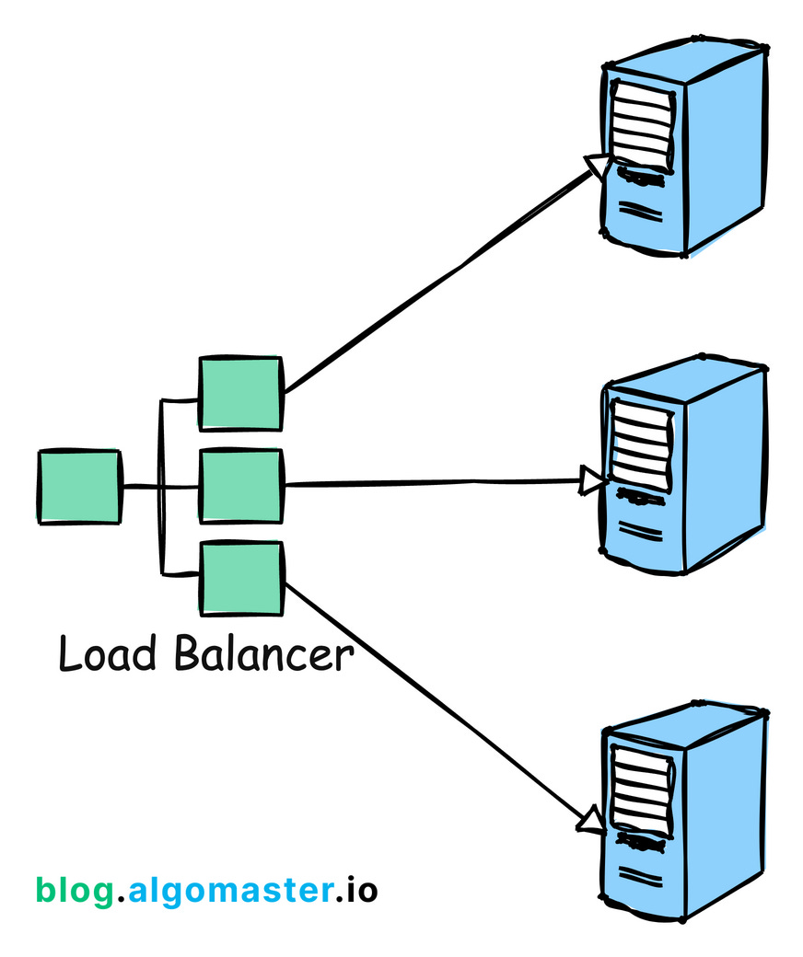](https://substackcdn.com/image/fetch/f_auto,q_auto:good,fl_progressive:steep/https%3A%2F%2Fsubstack-post-media.s3.amazonaws.com%2Fpublic%2Fimages%2F43054028-1249-4e9b-a243-04f5b496b794_872x1040.png)](https://substackcdn.com/image/fetch/f_auto,q_auto:good,fl_progressive:steep/https%3A%2F%2Fsubstack-post-media.s3.amazonaws.com%2Fpublic%2Fimages%2F43054028-1249-4e9b-a243-04f5b496b794_872x1040.png" \t "_blank)

Example: Google employs load balancing extensively across its global infrastructure to distribute search queries and traffic evenly across its massive server farms.

4. Caching

Store frequently accessed data in-memory (like RAM) to reduce the load on the server or database. Implement caching can dramatically improve response times.

[[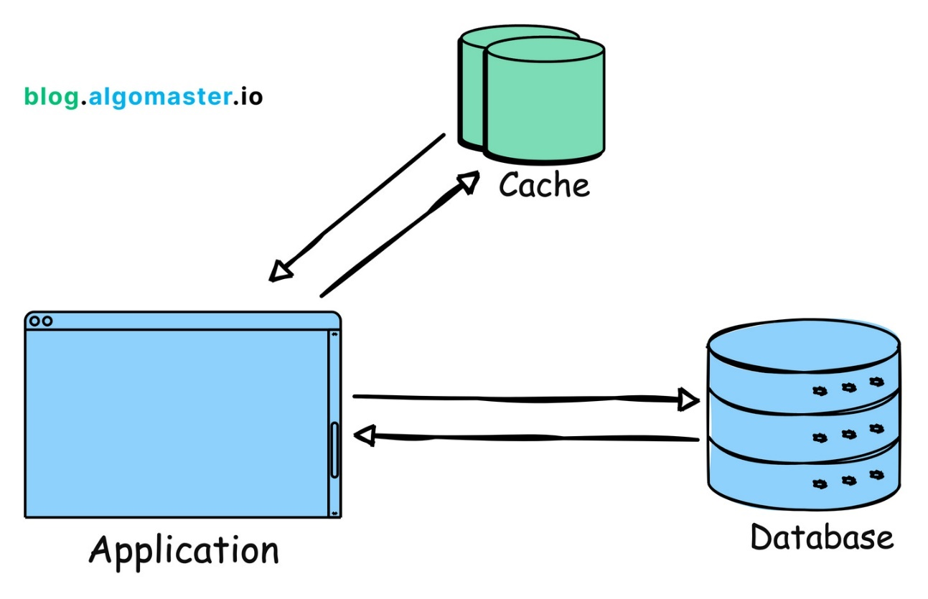](https://substackcdn.com/image/fetch/f_auto,q_auto:good,fl_progressive:steep/https%3A%2F%2Fsubstack-post-media.s3.amazonaws.com%2Fpublic%2Fimages%2Fd1ca3483-a238-49d8-94db-f7a3431d4c5b_1446x938.png)](https://substackcdn.com/image/fetch/f_auto,q_auto:good,fl_progressive:steep/https%3A%2F%2Fsubstack-post-media.s3.amazonaws.com%2Fpublic%2Fimages%2Fd1ca3483-a238-49d8-94db-f7a3431d4c5b_1446x938.png" \t "_blank)

Example: Reddit uses caching to store frequently accessed content like hot posts and comments so that they can be served quickly without querying the database each time.

5. Content Delivery Networks (CDNs)

Distribute static assets (images, videos, etc.) closer to users. This can reduce latency and result in faster load times.

Example: Cloudflare provides CDN services, speeding up website access for users worldwide by caching content in servers located close to users.

[[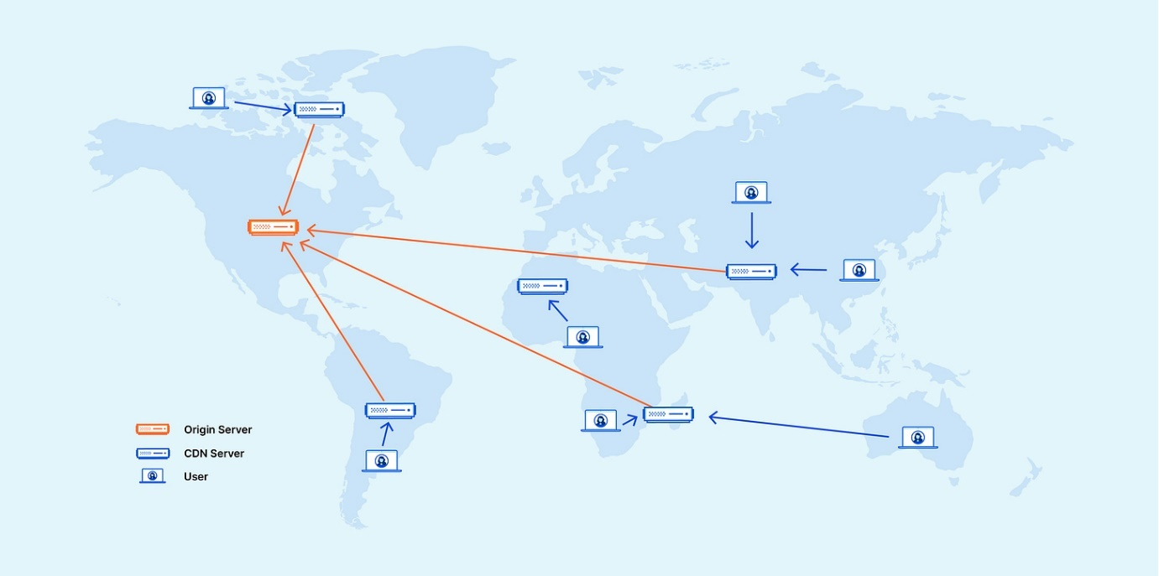](https://substackcdn.com/image/fetch/f_auto,q_auto:good,fl_progressive:steep/https%3A%2F%2Fsubstack-post-media.s3.amazonaws.com%2Fpublic%2Fimages%2F53e92b3d-791e-4951-8b6b-eb1d9b2bcea2_5667x2834.png)](https://substackcdn.com/image/fetch/f_auto,q_auto:good,fl_progressive:steep/https%3A%2F%2Fsubstack-post-media.s3.amazonaws.com%2Fpublic%2Fimages%2F53e92b3d-791e-4951-8b6b-eb1d9b2bcea2_5667x2834.png" \t "_blank)

Credit: https://www.cloudflare.com/learning/cdn/what-is-a-cdn/

Subscribe to receive new posts every week.

Top of Form

Subscribe

Bottom of Form

6. Partitioning

Split data or functionality across multiple nodes/servers to distribute workload and avoid bottlenecks.

[[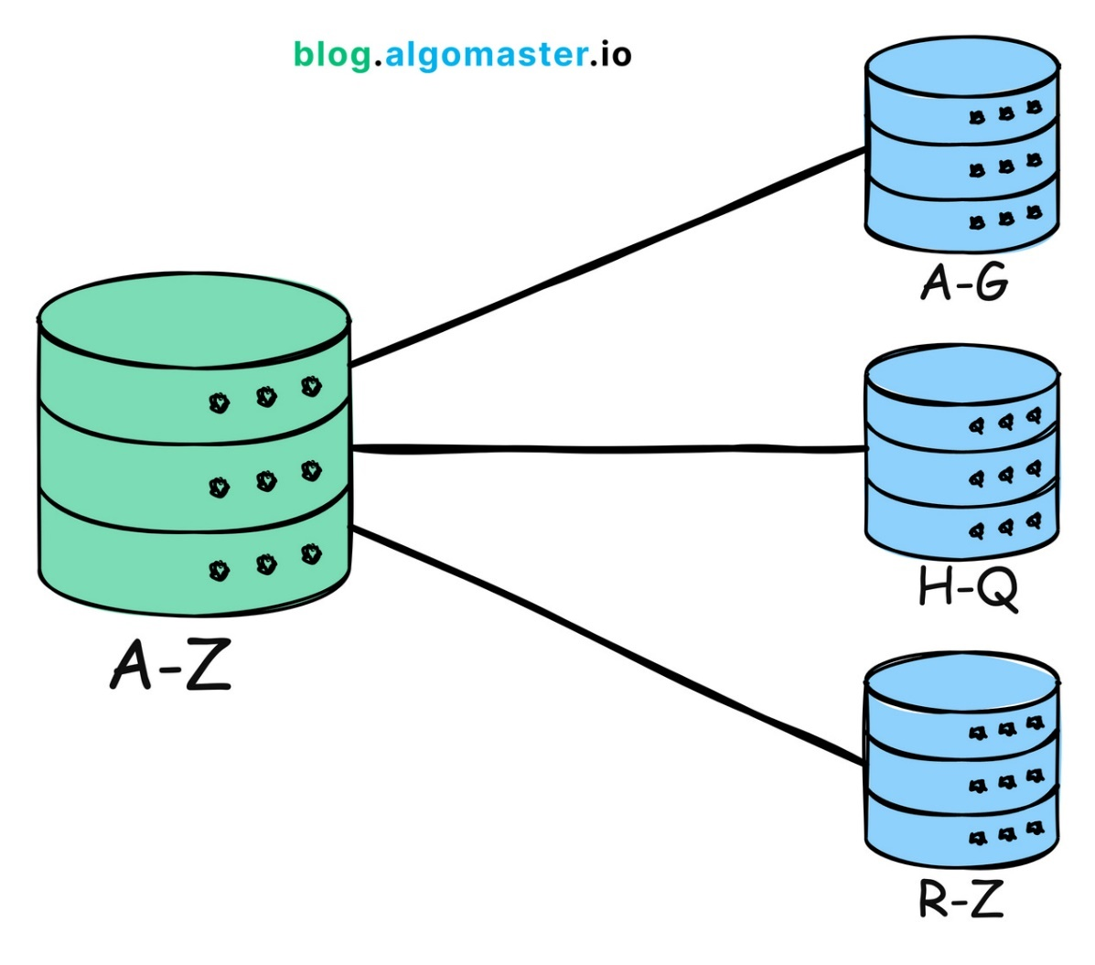](https://substackcdn.com/image/fetch/f_auto,q_auto:good,fl_progressive:steep/https%3A%2F%2Fsubstack-post-media.s3.amazonaws.com%2Fpublic%2Fimages%2F160a3d79-62ff-4406-b3cb-059b2788625f_1268x1122.png)](https://substackcdn.com/image/fetch/f_auto,q_auto:good,fl_progressive:steep/https%3A%2F%2Fsubstack-post-media.s3.amazonaws.com%2Fpublic%2Fimages%2F160a3d79-62ff-4406-b3cb-059b2788625f_1268x1122.png" \t "_blank)

Example: Amazon DynamoDB uses partitioning to distribute data and traffic for its NoSQL database service across many servers, ensuring fast performance and scalability.

7. Asynchronous communication

Defer long-running or non-critical tasks to background queues or message brokers. This ensures your main application remains responsive to users.

Example: Slack uses asynchronous communication for messaging. When a message is sent, the sender's interface doesn't freeze; it continues to be responsive while the message is processed and delivered in the background.

8. Microservices Architecture

Break down your application into smaller, independent services that can be scaled independently. This improves resilience and allows teams to work on specific components in parallel.

[[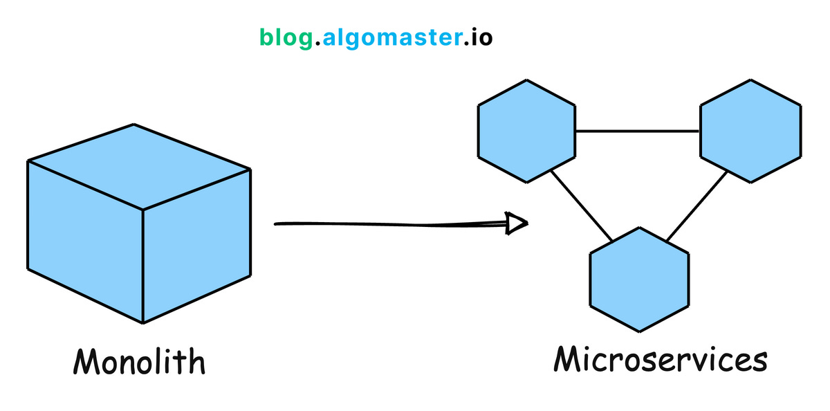](https://substackcdn.com/image/fetch/f_auto,q_auto:good,fl_progressive:steep/https%3A%2F%2Fsubstack-post-media.s3.amazonaws.com%2Fpublic%2Fimages%2F5c384f81-f732-4a3f-b028-a4b07b5adcac_1200x594.png)](https://substackcdn.com/image/fetch/f_auto,q_auto:good,fl_progressive:steep/https%3A%2F%2Fsubstack-post-media.s3.amazonaws.com%2Fpublic%2Fimages%2F5c384f81-f732-4a3f-b028-a4b07b5adcac_1200x594.png" \t "_blank)

Example: Uber has evolved its architecture into microservices to handle different functions like billing, notifications, and ride matching independently, allowing for efficient scaling and rapid development.

9. Auto-Scaling

Automatically adjust the number of active servers based on the current load. This ensures that the system can handle spikes in traffic without manual intervention.

[[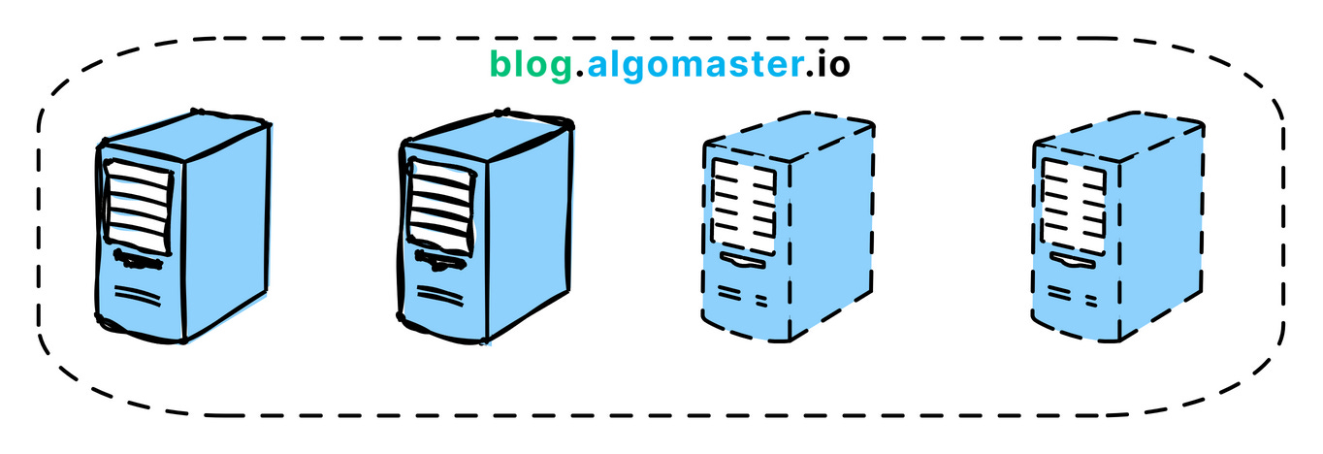](https://substackcdn.com/image/fetch/f_auto,q_auto:good,fl_progressive:steep/https%3A%2F%2Fsubstack-post-media.s3.amazonaws.com%2Fpublic%2Fimages%2Ff7273144-6b31-4636-bf2e-d9c39f6e2af8_1364x468.png)](https://substackcdn.com/image/fetch/f_auto,q_auto:good,fl_progressive:steep/https%3A%2F%2Fsubstack-post-media.s3.amazonaws.com%2Fpublic%2Fimages%2Ff7273144-6b31-4636-bf2e-d9c39f6e2af8_1364x468.png" \t "_blank)

Example: AWS Auto Scaling monitors applications and automatically adjusts capacity to maintain steady, predictable performance at the lowest possible cost.

10. Multi-region Deployment

Deploy the application in multiple data centers or cloud regions to reduce latency and improve redundancy.

Example: Spotify uses multi-region deployments to ensure their music streaming service remains highly available and responsive to users all over the world, regardless of where they are located.

Thank you so much for reading.

**Summary of differences: throughput vs. latency**

|  |  |  |
| --- | --- | --- |
|  | Throughput | Latency |
| What does it measure? | Throughput measures the volume of data that passes through a network in a given period. Throughput impacts how much data you can transmit in a period of time. | Latency measures the time delay when sending data. A higher latency causes a network delay. |
| How to measure? | Manually calculate throughput by sending a file or using network testing tools. | Calculate latency by using ping times. |
| Unit of measurement | Megabytes per second (MBps). | Milliseconds (ms). |
| Impacting factors | Bandwidth, network processing power, packet loss, and network topology. | Geographical distances, network congestion, transport protocol, and network infrastructure. |

**RATE LIMITING**

**How Does Rate Limiting Work?**

Rate limiting works within applications, not in the web server. Rate limiting typically involves tracking the IP addresses where requests originate and identifying the time lapsed between requests. IP addresses are the application’s main way to identify who has made each request.

Rate-limiting solutions work by measuring the elapsed time between every request from a given IP address and tracking the number of requests made in a set timeframe. If one IP address makes too many requests within the specified timeframe, the rate-limiting solution throttles the IP address and doesn’t fulfill its requests for the next timeframe.

Rate-limited applications can tell individual users to slow down if they make requests too frequently. It’s akin to police officers pulling over drivers that exceed the speed limit or parents telling their children not to eat too much sugar in a short period.

**Types of Rate Limits**

Administrators can define different parameters and methods and parameters when setting a rate limit. An organization’s chosen rate-limiting technique depends on the objective and the required level of restriction. Here are three main approaches to rate limiting that an organization might implement:

* User rate limits—this is the most popular rate-limiting method. It identifies the number of requests a given user makes, usually by tracking the user’s IP address or API key. Users that exceed the specified rate limit will trigger the application to deny any further requests until the rate-limited timeframe resets. Alternatively, users can contact the developers to increase the rate limit.
* Geographic rate limits—developers can further secure applications in a given geographic region by setting a rate limit for each specific region for a specified timeframe. For example, developers might predict that users in a given region will be less active between midnight and 9:00 am and define a lower rate limit for this timeframe. This approach helps prevent suspicious traffic and further reduces the risk of an attack.
* Server rate limits—developers can set rate limits at the server level if they define a specific server to handle parts of an application. This approach provides more flexibility, allowing the developers to increase the rate limit on commonly used servers while decreasing the traffic limit on less active servers.

What Are the Algorithms Used for Rate Limiting?

There are several types of rate-limiting algorithms.

Fixed-window Rate Limiting

Fixed-window rate limiting algorithms restrict the number of requests allowed during a given timeframe (window). For instance, a server’s rate-limiting component might implement an algorithm that accepts up to 200 API requests per minute. There is a fixed timeframe starting from a specified time—the server will not serve more than 200 requests between 9:00 and 9:01, but the window will reset at 9:01, allowing another 200 requests until 9:02.

Developers can implement a fixed-window algorithm at the server or user level. Implementing the algorithm at the user level will restrict each user to 200 requests per minute. In contrast, a server-level algorithm will restrict the server, meaning that all users combined can make up to 200 requests per minute.

**Leaky Bucket Rate Limiting**

Leaky bucket rate limiting algorithms differ from fixed-window algorithms because they don’t rely on specified timeframes. They focus on the fixed length of request queues without considering the time. The server will service requests on a first-come, first-serve basis. New requests join the back of the queue. The server will drop a new request if it arrives when the queue is full.

**Sliding-window Rate Limiting**

Sliding-window rate limiting algorithms are similar to fixed-window algorithms except for the starting point of each time window. With sliding-window rate limiting, the timeframe only starts when a user makes a new request, not a predetermined time. For instance, if the first request arrives at 9:00:24 am (and the rate limit is 200 per minute), the server will allow up to 200 requests until 9:01:24.

Sliding-window algorithms help solve the issues affecting requests in fixed-window rate limiting. They also mitigate the starvation issue facing leaky bucket rate limiting by providing more flexibility.

**What is fault tolerance?**

**Fault tolerance** describes a system’s ability to handle errors and outages without any loss of functionality. It is a critical capability, especially in cloud computing, where reliability and uptime are paramount.

For example, here’s a simple demonstration of comparative fault tolerance in the database layer. In the diagram below, **Application 1** is connected to a single database instance. **Application 2** is connected to two database instances — the primary database and a standby replica.

[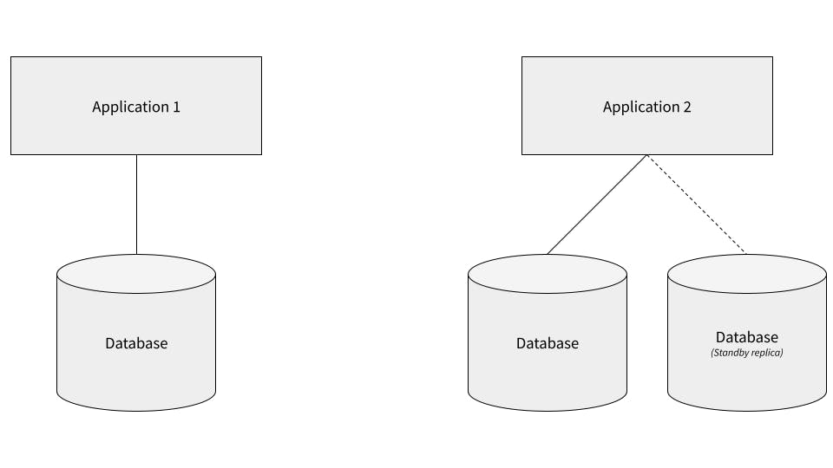](https://images.ctfassets.net/00voh0j35590/7yCAJlmKrfVY9RxAKf1ehM/287085f37f1869e46939c459d07ba6a4/fault-tolerance-comparative-application-architecture-illustration.jpg)

In this scenario, Application 2 is more fault tolerant. If its primary database goes offline, it can switch over to the standby replica and continue operating as usual.

Application 1 is not fault tolerant. If its database goes offline, all application features that require access to the database will cease to function.

Of course, this is just a simple example. In reality, fault tolerance must be considered in every layer of a system (not just the database), and there are degrees of fault tolerance. While Application 2 is more fault tolerant than Application 1, it’s still less fault tolerant than many modern applications. (See examples of fault-tolerant application architecture.)

What is fault tolerance in cloud computing? It involves designing systems that can automatically recover from failures, ensuring minimal disruption to services. This is essential for maintaining customer trust and business continuity.

Fault tolerance can also be achieved in a variety of ways. These are some of the most common approaches to achieving fault tolerance:

**Multiple hardware systems** capable of doing the same work. For example, Application 2 in our diagram above could have its two databases located on two different physical servers, potentially in different locations. That way, if the primary database server experiences an error, a hardware failure, or a power outage, the other server might not be affected.

**Multiple instances of software** capable of doing the same work. For example, many modern applications make use of containerization platforms such as Kubernetes so that they can run multiple instances of software services. One reason for this is so that if one instance encounters an error or goes offline, traffic can be routed to other instances to maintain application functionality.

**Backup sources of power,** such as generators, are often used in on-premises systems to protect the application from being knocked offline if power to the servers is impacted by, for example, the weather. That type of outage is more common than you might expect.

**Strong Consistency vs Eventual Consistency**

Master-Slave Model (Image courtesy: [Dropbox](https://cfl.dropboxstatic.com/static/images/logo_catalog/dropbox_logo_glyph_m1.svg?ref=hackernoon.com), [Apple](https://images.techhive.com/images/article/2014/12/macbook_air-100538062-large.jpg?ref=hackernoon.com), [Seagate](http://i.ebayimg.com/00/s/MjkyWDUwMA==/z/4zYAAMXQVT9SsmxD/$_3.JPG?set_id=2&ref=hackernoon.com))

Every fortnight, I update my external Hard Disk with revised and newly written *Tech Notes* and Dropbox gets updated as soon as I connect my laptop to the internet.

*Here, I am using Hard Disk and Dropbox as source of reading Tech Notes while laptop is being used for reading as well as writing them. (Master-Slave Model)*

*Redundancy introduces Reliability.*

Now let’s get to the point.

**Case 1: Eventual Consistency**

Whenever we use multiple replicas of a database to store data and let’s say a write request comes to one of the replicas. In such a situation, Databases had to discover a strategy to make this write request at one replica reach other replicas so that they all could also write data of the request and become consistent.

*Consistency here means that a read request for an entity made to any of the nodes of the database should return the same data.*

Eventual consistency makes sure that data of each node of the database gets consistent eventually. Time taken by the nodes of the database to get consistent may or may not be defined.

Data getting consistent eventually means it will take time for updates to reach other replicas. So what?This implies that if someone reads from a replica which is not updated yet (since replicas are updated eventually) then it may return stale data.

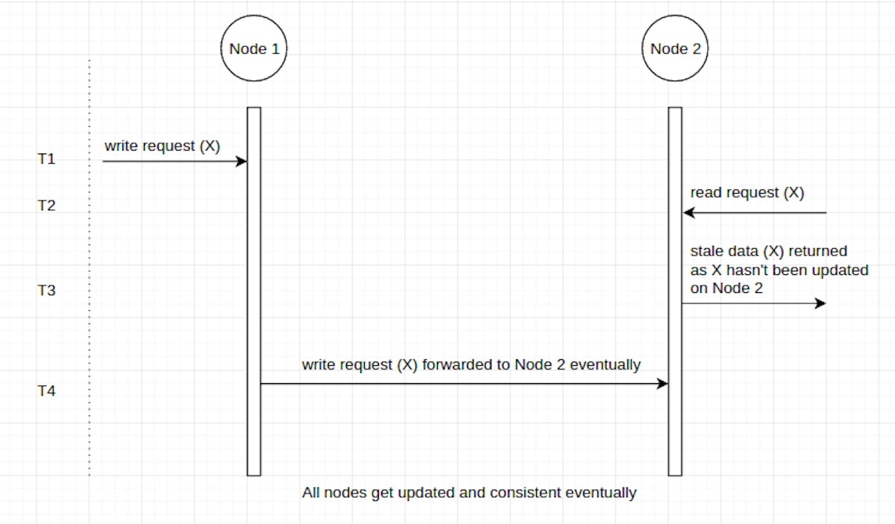

My Hard Disk also keeps stale data for a period of 15 days as it gets updated fortnightly. Let’s assume John, my friend comes after few days of updation and asks for my Hard Disk.

**John:** I want your hard disk to read your Tech Notes.**I:** Sure, why not. But it hasn’t been updated since last few days.**John:** I am fine with it.

Now Hard Disk was supplied to John immediately *(low latency)* at the risk of having stale data in it. But I am sure about the fact that it will get updated when the next fortnight starts.

*Eventual consistency offers low latency at the risk of returning stale data*

While on the other hand, we have something known as Strong Consistency.

**Case 2: Strong Consistency**

It says data will get passed on to all the replicas as soon as a write request comes to one of the replicas of the database.But during the time these replicas are being updated with new data, response to any subsequent read/write requests by any of the replicas will get delayed as all replicas are busy in keeping each other consistent.

As soon as they become consistent, they start to take care of the requests that have come at their door.

*Nothing is for free.*

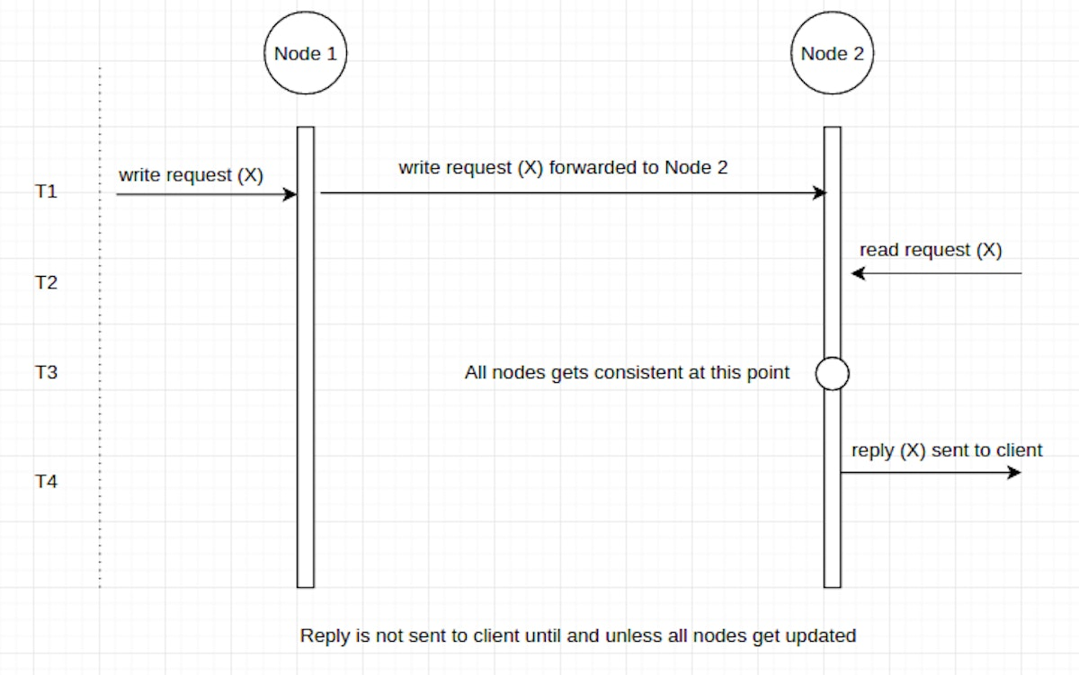

This time my friend Veronica comes and asks for my Tech Notes.

**Veronica:** I want your latest Tech Notes.**I:** Sure, why not. I will share a Dropbox link with you.But Veronica, access it after few minutes as I have written anew Tech Note on laptop which will get synced with myDropbox account in 2–3 minutes.

Now Veronica was able to access up-to-date *Tech Notes* but after few minutes of delay.

**Conclusion**

* Strong Consistency offers up-to-date data but at the cost of **high latency**.
* While Eventual consistency offers **low latency** but may reply to read requests with **stale data** since all nodes of the database may not have the updated data.

Please hit the ♥ button if you liked the article so that other Medium users might find it and dig it too.

**DISTRIBUTED TRACING**

**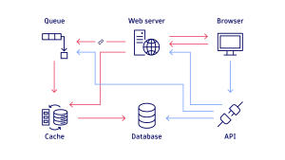**

**What is distributed tracing?**

The evolution of distributed tracing

Previously, when businesses primarily built monolithic applications, it was relatively straightforward to see what transpired within them. With the rise of [service-oriented architectures](https://www.dynatrace.com/news/blog/what-are-microservices/), however, it became harder to understand how specific transactions traveled through the various tiers of an application. This, in turn, made it difficult to pinpoint the root causes underlying latency and delays in execution time.

This complexity also created internal collaboration challenges. If an organization was unable to identify the affected microservice, then it could not determine which team was responsible for addressing the issue. With so little visibility into activity in the environment, it was easy for troubleshooting sessions to devolve into war rooms where teams blamed one another.

Organizations recognized the need for better observability of their application environments. However, creating a solution from scratch using internal development resources was too costly and time-consuming, and it would slow the pace of innovation. Distributed tracing now meets this need, enabling companies to better understand the performance issues affecting their microservices environments.

**What are the different types of tracing?**

Organizations may use different types of distributed tracing, including the following:

Code tracing. With this method, a developer manually interprets the results of each line of code within an application. Code tracing tracks the variable values as they change during execution to determine the output of the code. This process works particularly well with smaller blocks of code, enabling them to be analyzed without having to run the entire application. Code tracing is considered a foundational skill that leads to better code writing.

Data tracing. Developers use data tracing to perform data accuracy and quality checks on critical data elements (CDEs) that are essential from a business perspective. They also use this method to trace those prioritized CDEs back to their source systems to be proactively monitored.

Program trace. This command delivers an index of the instructions that have been executed, as well as the data that has been referenced while an application has been running. Debuggers and other code analysis tools often use program trace to improve code as part of the software development process.

The benefits of distributed tracing

Distributed tracing offers teams and organizations multiple benefits, including improved application performance, improved compliance with service-level agreements (SLAs), and faster time to market. Some of the most valuable benefits of distributed tracing include the following:

* Reduced mean time to detect (MTTD) and mean time to repair (MTTR). Distributed tracing enables teams to get to the bottom of application performance issues faster, often before users notice anything wrong. Upon discovering an issue, they can rapidly identify the root cause and address it. [Observability](https://www.dynatrace.com/news/blog/what-is-observability-2/) also provides teams with early warnings when microservices are in poor health and can highlight performance bottlenecks anywhere in the software stack as well as code that should be optimized.
* Improved compliance with SLAs. The organization can also maintain a high-quality user experience and improve its compliance with SLAs.
* Protected bottom-line growth. This minimizes potential effects to the bottom line and helps the organization maintain a steady flow of revenue.
* Faster time to market. As a result, organizations can get to market with new products and services much more quickly, gaining a competitive advantage.
* Improved internal collaboration. Because distributed tracing pinpoints the exact areas where issues lie, it also helps to boost collaboration and communication across teams. This improves the working relationships that are crucial for both timely troubleshooting and delivering innovations that grow the business.

The challenges of distributed tracing

Although distributed tracing gives organizations many advantages, it can also present some challenges and limitations. They include the following:

* Manual instrumentation. Although distributed tracing is meant to save teams time, some tools require developers to manually instrument or adjust their code before allowing them to configure distributed tracing requests. This requirement can be time-consuming and can accidentally result in code errors. Some teams may apply standardized processes to this task, potentially causing them to overlook some traces.
* Limited to back-end coverage. Some tools that don’t take an end-to-end approach to distributed tracing only generate a trace ID for a request when it reaches the first back-end service, obscuring the corresponding user session on the frontend. This makes it unnecessarily difficult to identify the root cause of a problematic request and determine whether the back-end or front-end team should address it.
* Head-based sampling. If a tracing tool simply samples traces randomly at the start of each request, some traces may fall through the cracks. As a result. certain traces may be missing or incomplete. This means organizations can’t always sample high-priority traces, such as high-value transactions or requests from specific customers. An advanced observability solution can encompass all of an organization’s traces, orienting itself toward tail-based decisions instead of taking a head-based sampling approach. This way, the organization can capture complete traces that are tagged with specific priority characteristics.

The inner workings of distributed tracing and why we need it

Distributed tracing is essential to monitoring, debugging, and optimizing distributed software architecture such as microservices — especially in dynamic [microservices architectures](https://www.dynatrace.com/news/blog/what-are-microservices/). It tracks a single request by collecting and analyzing data on every interaction with every service the request touches.

Each activity — called a segment or span — that is triggered by a request is recorded as it moves both through and across services. Information collected includes a name, start and end timestamps, and other metadata. When one activity — a “parent” span — is completed, the next activity passes to its “child” span. The distributed trace places these spans in their correct order.

Businesses need distributed tracing to help streamline the complexity of their modern application environments. With distributed applications, there are more potential points of failure across the entire application stack. This means it can take far more time to identify root causes when issues arise. The resulting complexity directly affects a company’s ability to maintain its SLAs and provide a stellar user experience.

Distributed tracing helps teams understand more quickly how each microservice is performing. This understanding helps them resolve issues rapidly, increase customer satisfaction, ensure steady revenue, and preserve time for teams to innovate. This way, businesses can take full advantage of the benefits modern application environments offer while minimizing the challenges that their inherent complexity can also create.

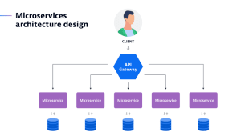

When do you use distributed tracing?

When multiple microservices are linked to a request, it becomes more challenging to understand the relationships between them and determine how they work together to fulfill that request. In microservices or serverless architectures especially, distributed tracing is essential for quickly getting answers to specific questions.

DevOps, operations teams, and site reliability engineers (SREs) all find distributed tracing useful for the following situations:

* understanding the current health of microservices within a distributed system;
* rapidly identifying the root cause of errors in the same setting; and
* spotting performance bottlenecks that either currently affect or potentially impact the user experience.

Distributed tracing can also be a strategic asset for proactively optimizing problematic or inefficient code within certain microservices.

How is distributed tracing different from logging?

Log files contain valuable details that are a crucial part of distributed tracing, but logging and distributed tracing are not the same. Writing log files is as much an art as it is a science. Logs must contain enough information to trigger the appropriate action, but be lightweight to not bog down system resources. To understand the difference, it’s helpful to first be aware of two types of logging:

1. centralized logging
2. distributed logging

What is centralized logging?

Centralized logging is a method of recording activity wherein a team transports and stores the logs generated by a service or component in a single location. This enables teams to centrally track error reporting and related data. In a microservices environment, teams do this by aggregating the logs from multiple microservices into a central location so they can reference and analyze them more easily. The focus of this type of logging is specifically to identify errors that occur within the application and to locate the microservice from which they originated. This becomes more challenging in distributed environments in which many thousands of microservices generate their logging data.

Although more convenient for developers, centralized logging requires that systems transport logs from their origin to a single location. This practice can consume a considerable amount of network resources. As a result, this may sometimes lead to network performance issues that affect other applications and services.

What is distributed logging?

In contrast, distributed logging is a method of recording activity in logs that are located throughout the computing environment, often across multiple clouds. Organizations may choose this approach instead of centralized logging to reduce the burden of constantly transporting and storing logs in a single location.

Some log storage solutions are also finicky, requiring closer proximity to the device that generates the logs. Large-scale applications, such as those composed of multiple microservices, tend to continually generate large quantities of logs. In these cases, teams may prefer to use a distributed logging approach.

Teams can use logging and distributed tracing in parallel. Organizations often begin with logging and may add distributed tracing as their application environment becomes more complex, for example, when they use microservices.

The impact of tracing through distributed systems

Distributed tracing can easily follow a request through hundreds of separate system components, and it does more than just record the [end-to-end journey of a request](https://www.dynatrace.com/news/blog/distributed-tracing-with-w3c-trace-context-for-improved-end-to-end-visibility/). It can also provide real-time insight into system health. This enables IT, [DevSecOps](https://www.dynatrace.com/news/blog/what-is-devsecops/), and [SRE](https://www.dynatrace.com/news/blog/what-is-site-reliability-engineering/) teams to:

* Report on the health of applications and microservices to identify degraded states before a failure occurs.
* Detect unforeseen behavior that results from automated scaling, making it easier to prevent and recover from failures.
* Analyze how end-users experience the system in terms of average response times, error rates, and other digital experience metrics.
* Monitor key performance metrics with interactive visual dashboards.
* Debug systems, isolate bottlenecks, and resolve code-level performance issues.
* Identify and troubleshoot the root cause of unseen problems.

Where traditional monitoring methods struggle

To achieve its goal of enabling data-driven decision-making, distributed tracing relies on observability data from across all environments. Traditional software monitoring platforms collect observability data in three main formats, which are often referred to as the [three pillars of observability](https://www.dynatrace.com/resources/ebooks/three-pillars-of-observability/):

* Logs. Timestamped records of an event or events.
* Metrics. Numeric representation of data measured over a set period.
* Traces. A record of events that occur along the path of a single request.

In the past, platforms made good use of this data, such as following a request through a single application domain. Before the advent of containers, [Kubernetes](https://www.dynatrace.com/news/blog/what-is-kubernetes-2/), or microservices, gaining visibility into monolithic systems was simple. But in today’s vastly more complex and distributed environments, such data offers no overarching view of system health.

Log aggregation, the practice of combining logs from many different services, is a good example. It may give a snapshot of the activity within a collection of individual services. Still, the logs lack contextual metadata to provide the full picture of a request as it travels downstream through possibly [millions of application dependencies](https://www.dynatrace.com/platform/artificial-intelligence/dependency-detection/). On its own, this method simply isn’t sufficient for troubleshooting in distributed systems. This is where observability and, specifically, distributed tracing come in.

As opposed to simple monitoring, observability is the standard for understanding and gaining visibility into apps and services. It helps to explore the properties and patterns within an environment that are not defined in advance. Distributed tracing is one of several capabilities vital to achieving the observability that modern enterprises demand.

The impact of tracing through distributed systems

Distributed tracing can easily follow a request through hundreds of separate system components, and it does more than just record the [end-to-end journey of a request](https://www.dynatrace.com/news/blog/distributed-tracing-with-w3c-trace-context-for-improved-end-to-end-visibility/). It can also provide real-time insight into system health. This enables IT, [DevSecOps](https://www.dynatrace.com/news/blog/what-is-devsecops/), and [SRE](https://www.dynatrace.com/news/blog/what-is-site-reliability-engineering/) teams to do the following:

* Report on the health of applications and microservices to identify degraded states before a failure occurs.
* Detect unforeseen behavior that results from automated scaling, making it easier to prevent and recover from failures.
* Analyze how end users experience the system in terms of average response times, error rates, and other digital experience metrics.
* Monitor key performance metrics with interactive visual dashboards.
* Debug systems, isolate bottlenecks, and resolve code-level performance issues.
* Identify and troubleshoot the root cause of unseen problems.

| **Criteria** | **Batch Processing** | **Stream Processing** |
| --- | --- | --- |
| Nature of Data | Processed in chunks or batches. | Processed continuously, one event at a time. |
| Latency | High latency: insights are obtained after the entire batch is processed. | Low latency: insights are available almost immediately or in near-real-time. |
| Processing Time | Scheduled (e.g., daily, weekly). | Continuous. |
| Infrastructure Needs | Significant resources might be required but can be provisioned less frequently. | Requires systems to be always on and resilient. |
| Throughput | High: can handle vast amounts of data at once. | Varies: optimized for real-time but might handle less data volume at a given time. |
| Complexity | Relatively simpler as it deals with finite data chunks. | More complex due to continuous data flow and potential order or consistency issues. |
| Ideal Use Cases | Data backups, ETL jobs, monthly reports. | Real-time analytics, fraud detection, live dashboards. |
| Error Handling | Detected after processing the batch; might need to re-process data. | Needs immediate error-handling mechanisms; might also involve later corrections. |
| Consistency & Completeness | Data is typically complete and consistent when processed. | Potential for out-of-order data or missing data points. |
| Tools & Technologies | Hadoop, Apache Hive, batch-oriented Apache Spark. | Apache Kafka, Apache Flink, Apache Storm. |

**𝐅𝐚𝐧𝐭𝐚𝐬𝐭𝐢𝐜 𝐅𝐨𝐮𝐫 𝐨𝐟 𝐒𝐲𝐬𝐭𝐞𝐦 𝐃𝐞𝐬𝐢𝐠𝐧 (Scalability, Availability, Reliability, and Performance)**They are the most critical components to crafting successful software systems.   
Let’s look at each of them with implementation techniques:   
   
🔸 𝐒𝐜𝐚𝐥𝐚𝐛𝐢𝐥𝐢𝐭𝐲   
Scalability ensures that your application can handle more load without compromising performance.   
   
🔸 𝐀𝐯𝐚𝐢𝐥𝐚𝐛𝐢𝐥𝐢𝐭𝐲   
Availability makes sure that your application is always ready to serve the users and downtime is minimal.   
   
🔸 𝐑𝐞𝐥𝐢𝐚𝐛𝐢𝐥𝐢𝐭𝐲   
Reliability is about building software that consistently delivers correct results.   
   
🔸 𝐏𝐞𝐫𝐟𝐨𝐫𝐦𝐚𝐧𝐜𝐞   
Performance is the ability of a system to carry out its tasks at an expected rate under peak load using available resources.   


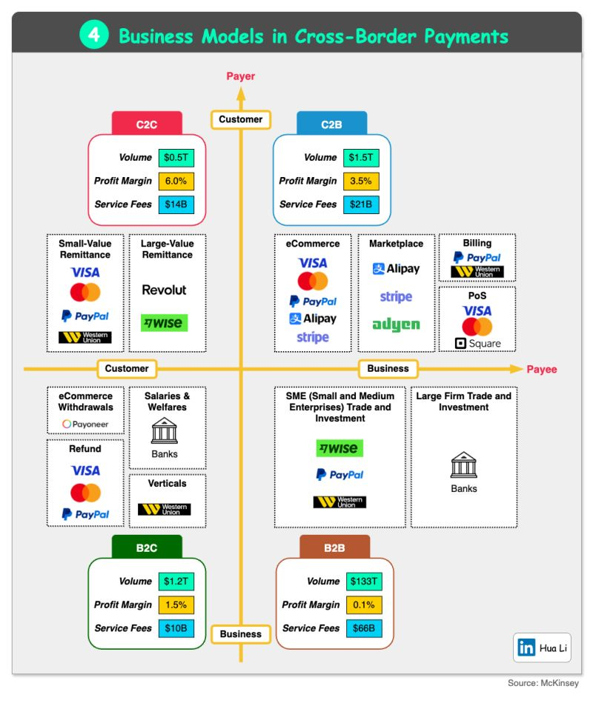



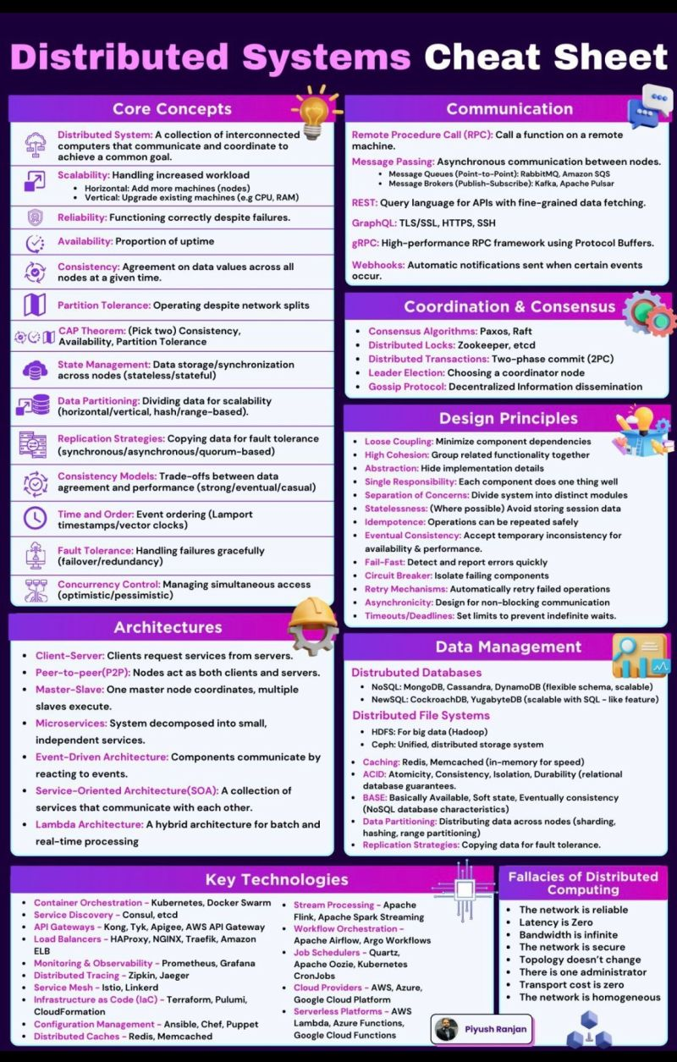

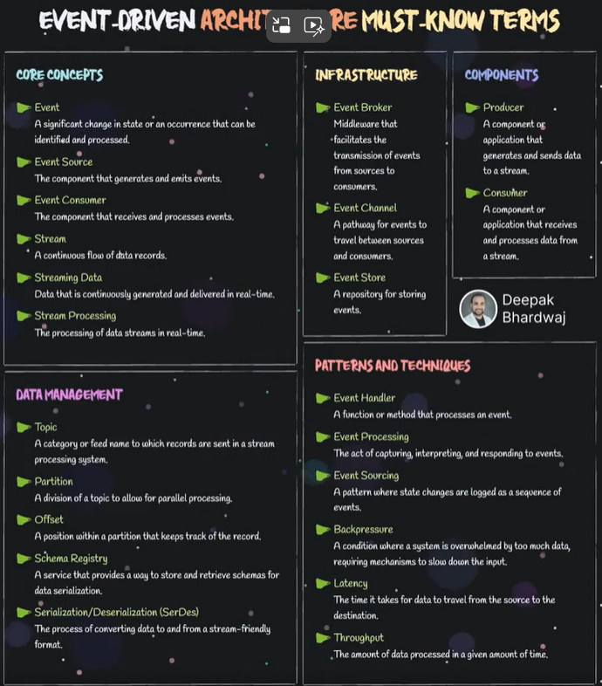

Event-Driven Architecture Must-Know Terms  
  
Event-driven architecture (EDA) is essential for building scalable and responsive systems. Understanding these concepts can help you design and manage efficient event-driven systems. Here are some must-know concepts:  
  
🔘 𝐂𝐨𝐫𝐞 𝐂𝐨𝐧𝐜𝐞𝐩𝐭𝐬:  
↳ Event: A significant change in state or an occurrence that can be identified and processed.  
↳ Event Source: The component that generates and emits events.  
↳ Event Consumer: The component that receives and processes events.  
↳ Stream: A continuous flow of data records.  
↳ Streaming Data: Data that is continuously generated and delivered in real-time.  
↳ Stream Processing: The processing of data streams in real time.  
  
🔘 𝐈𝐧𝐟𝐫𝐚𝐬𝐭𝐫𝐮𝐜𝐭𝐮𝐫𝐞:  
↳ Event Broker: Middleware that facilitates the transmission of events from sources to consumers.  
↳ Event Channel: A pathway for events to travel between sources and consumers.  
↳ Event Store: A repository for storing events.  
  
🔘 𝐂𝐨𝐦𝐩𝐨𝐧𝐞𝐧𝐭𝐬:  
↳ Producer: A component or application that generates and sends data to a stream.  
↳ Consumer: A component or application that receives and processes data from a stream.  
  
🔘 𝐃𝐚𝐭𝐚 𝐌𝐚𝐧𝐚𝐠𝐞𝐦𝐞𝐧𝐭:  
↳ Topic: A category or feed name to which records are sent in a stream processing system.  
↳ Partition: A division of a topic to allow for parallel processing.  
↳ Offset: A position within a partition that keeps track of the record.  
↳ Schema Registry: A service that provides a way to store and retrieve schemas for data serialisation.  
↳ Serialisation/Deserialization (SerDes): The process of converting data to and from a stream-friendly format.  
  
🔘 𝐏𝐚𝐭𝐭𝐞𝐫𝐧𝐬 𝐚𝐧𝐝 𝐓𝐞𝐜𝐡𝐧𝐢𝐪𝐮𝐞𝐬:  
↳ Event Handler: A function or method that processes an event.  
↳ Event Processing: Capturing, interpreting, and responding to events.  
↳ Event Sourcing: A pattern where state changes are logged as a sequence of events.  
↳ Backpressure: When a system is overwhelmed by too much data, requiring mechanisms to slow the input down.  
↳ Latency: The time it takes for data to travel from the source to the destination.  
↳ Throughput: The amount of data processed in a given amount of time.  
  
Understanding these terms is crucial for anyone working with event-driven systems. Mastering these concepts can enhance your system’s scalability and responsiveness.



Pro tip => These Authentication Mechanisms/Types are not limited just to microservices.  
  
[1.] 𝐀𝐏𝐈 𝐊𝐞𝐲𝐬  
◾ Simple, unique identifiers assigned to each client or service.  
◾ Sent as a header or query parameter with each request.  
◾ Best suited for internal services, less sensitive APIs, or for granting access to specific features.   
◾ Easy to implement and manage.  
◾ Not as secure as token-based methods. Keys can be easily leaked or stolen.  
  
[2.] 𝐁𝐚𝐬𝐢𝐜 𝐀𝐮𝐭𝐡𝐞𝐧𝐭𝐢𝐜𝐚𝐭𝐢𝐨𝐧  
◾ Username and password are sent in the Authorization header as base64 encoded string.  
◾ Simple to implement but requires HTTPS to be secure.  
◾ Suitable for simple scenarios with low-security requirements.  
◾ Widely supported and easy to understand.  
◾ Vulnerable to man-in-the-middle attacks if not used with HTTPS.  
◾ Passwords are sent in cleartext (even when encoded).  
  
[3.] 𝐉𝐒𝐎𝐍 𝐖𝐞𝐛 𝐓𝐨𝐤𝐞𝐧𝐬 (𝐉𝐖𝐓)  
◾ Self-contained tokens that carry user information and claims in a JSON payload.  
◾ Issued by an authentication server after successful login, then sent by the client in the Authorization header.  
◾ Widely used for stateless authentication in microservices, single sign-on (SSO) and authorization.  
◾ Stateless, secure, compact and can contain additional claims.  
◾ Requires proper key management for signing and verification.  
  
[4.] 𝐎𝐀𝐮𝐭𝐡 2.0  
◾ An authorization framework allowing third-party applications to obtain limited access to resources on behalf of the resource owner (user) without sharing credentials.  
◾ Uses various grant types (authorization code, implicit, client credentials, etc.) to obtain access tokens and refresh tokens.  
◾ Widely used for user authorization and delegated access to APIs.  
◾ Provides a standardized way to secure access to resources without sharing credentials.  
◾ Can be complex to implement and requires careful consideration of security vulnerabilities.  
  
[5.] 𝐎𝐩𝐞𝐧𝐈𝐃 𝐂𝐨𝐧𝐧𝐞𝐜𝐭 (𝐎𝐈𝐃𝐂)  
◾ An identity layer on top of OAuth 2.0 that provides user authentication and profile information.  
◾ Uses an ID token along with the access token to provide user identity information.  
◾ Used for authentication in conjunction with OAuth 2.0 for authorization.  
◾ Simplifies authentication by providing a standardized way to obtain user information.  
◾ Requires integration with an OIDC provider (e.g., Google, Okta).  
  
[6.] 𝐌𝐮𝐭𝐮𝐚𝐥 𝐓𝐋𝐒 (𝐦𝐓𝐋𝐒)  
◾ Both client and server authenticate each other using X.509 certificates.  
◾ Requires a certificate authority (CA) to issue and manage certificates.  
◾ Best suited for securing communication between internal services or highly sensitive APIs.  
◾ Strong security due to mutual authentication and encryption.  
◾ More complex to set up and manage compared to other mechanisms.

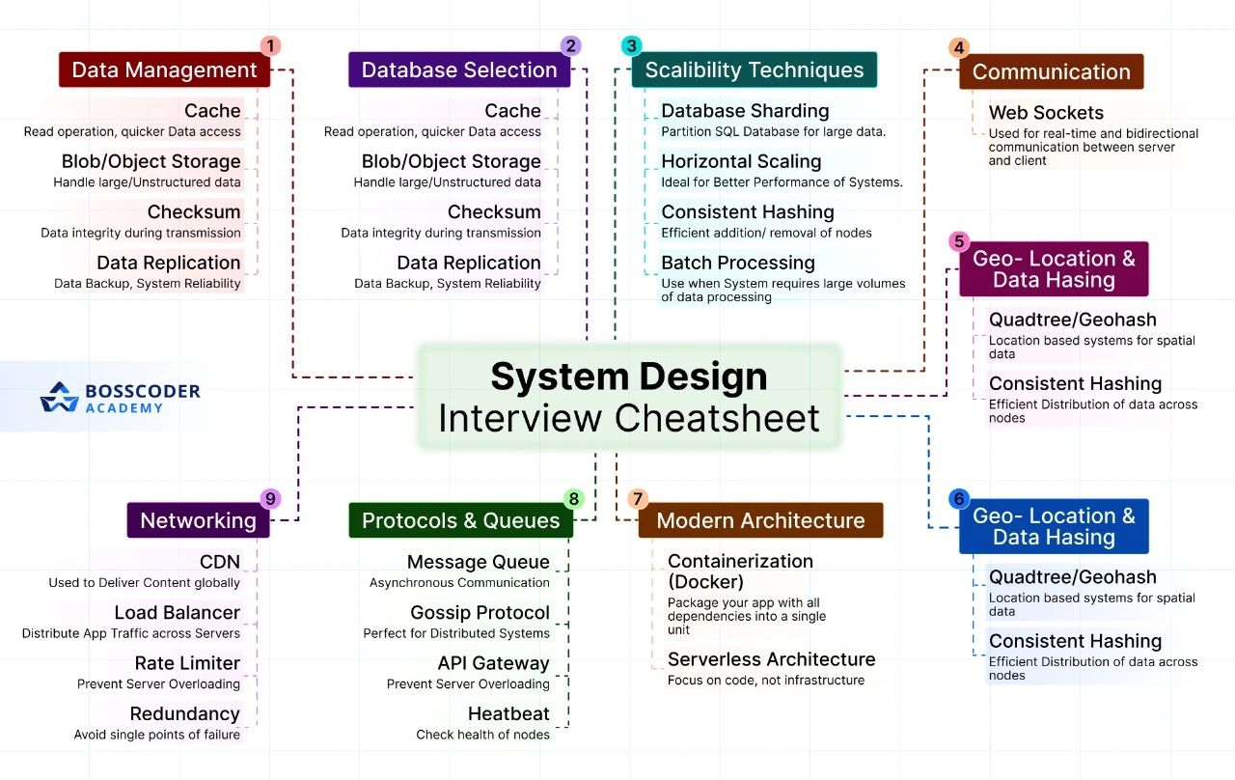

Focus on strengthening your foundational knowledge first. No matter the language you prefer start by building a solid understanding of core system design principles.  
  
  
🔸Data Management:  
 - Cache: Enhances data retrieval speed for quicker access.  
 - Blob/Object Storage: Ideal for managing large and unstructured data.  
 - Checksum: Ensures data integrity during transmission.  
 - Data Replication: Improves data backup and system reliability.  
  
🔸Scalability Techniques:  
 - Database Sharding: Splits SQL databases to manage large datasets.  
 - Horizontal Scaling: Increases system performance by adding more machines.  
 - Consistent Hashing: Efficiently adds or removes nodes.  
 - Batch Processing: Perfect for handling large volumes of data.  
  
🔸Geo-Location & Data Hashing:  
 - Quadtree/Geohash: Manages spatial data in location-based systems.  
 - Consistent Hashing: Distributes data efficiently across nodes.  
  
🔸Networking & Communication:  
 - Web Sockets: Enables real-time, bidirectional communication between server and client.  
 - CDN: Facilitates global content delivery.  
 - Load Balancer: Distributes application traffic to maintain performance.  
 - Rate Limiter & Redundancy: Prevents server overload and ensures system resilience.  
 - Message Queue: Supports asynchronous communication.  
 - Gossip Protocol: Ideal for distributed systems.  
 - API Gateway: Manages and protects APIs from overload.  
 - Heartbeat: Regularly checks the health of nodes.  
  
🔸Modern Architecture:  
 - Containerization (Docker): Packages applications with all dependencies for seamless deployment.  
 - Serverless Architecture: Lets you focus on code without worrying about infrastructure.  
  
Learning these concepts has been a game-changer for me, and I'm excited to apply them in real-world projects. If you're also into system design and architecture, let's connect and share insights!   
  
Now, if you’re a working professional preparing for Senior roles at Top PBCs, a good position & building a great career in a product company. I’d suggest checking Bosscoder Academy.



Understanding the various architectural patterns is essential  
  
Let's learn some commonly used architectural patterns  
  
1. Centralized & Decentralized Pattern: In a centralized pattern, A Server node AKA controller node, which manages the work distribution, and worker nodes, which do the actual work, are connected. In a Decentralized pattern, multiple server nodes can control the system, and they can make their own decisions. The known examples are blockchain and crypto.   
  
2. Layered Architecture: The system is divided into multiple layers (presentation, business, data), making components reusable and portable. Each layer is a collection of modules. The layers are dependent on each other. Think of a computer system as a sandwich with different layers. Each layer has its job (presentation, business, data), and they all work together.  
  
3. Pipe & Filter: The pipe and filter pattern is a standard method for organizing data transformation systems. In this pattern, individual filters carry out specific transformations on input data and pass the converted data to the next filter through a pipe. Image and text editors use this.  
  
4. Hexagonal: Also known as ports and adapters architecture, it takes input via an adapter to an application, and output is sent from that application through a port to an adapter  
  
5. Monolithic Architecture: This has business logic, UI, and data are tightly coupled and integrated and deployed as one entity  
  
6. Microservices Architecture: The services are broken down into small components that can be developed, managed, and deployed independently.   
  
7. MVC: The application is broken down into model, view, and controller. The model holds business logic, the view holds UI, and the controller handles user input and interactions.  
  
8. Broker Pattern: A middleman called a broker will integrate clients and servers. When a client requires a service, it sends a request to the broker, and then the broker forwards it to the appropriate service.  
  
9. Serverless: The underlying infrastrucutre is completely abstracted so that the team doesn't worry about the provision, deployment, and maintenance of the servers. Developers can focus on developing the applications.  
  
10. MVVM: Presentation, business logic, and data needs are segregated in this pattern. The view model integrates the model and view. Like a superhero team where each member has an extraordinary power  
  
11. Pub-Sub: A set of publishers publish the information to an event bus, and interested subscribers will consume the data; both don't have to know each other. Picture a group chat where some friends share excellent news (publishers), and others who want to know about it (subscribers) get the info. They don't have to talk directly.  
  
12. Event Driven: Based on external events, another system or component will act/make changes as needed. For example, A successful ordering system can trigger the generation of gift vouchers to the customer.

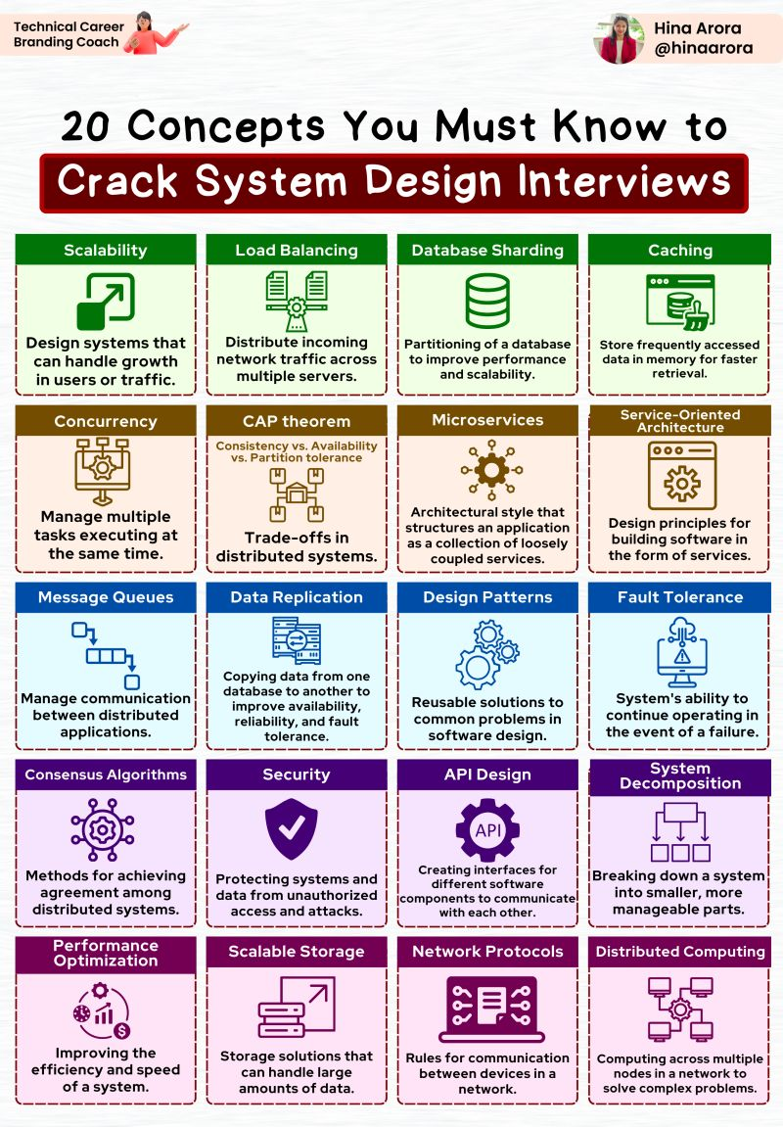

Here are 20 important concepts that every engineer should know:  
  
🔷 DNS: Translates domain names into IP addresses, enabling internet access.  
  
🔷 Load balancer: Distributes network traffic across servers for optimal resource utilization.  
  
🔷 API Gateway: Central entry point for API requests, handling routing, authentication, and rate limiting.  
  
🔷 CDN: Caches and delivers content closer to users, improving performance.  
  
🔷 Forward/Reverse Proxy: Enhances security and performance by accessing and directing requests.  
  
🔷 Caching: Stores frequently accessed data to reduce load and improve response times.  
  
🔷 Data Partitioning: Divides large datasets for efficient storage, retrieval, and processing.  
  
🔷 Database Replication: Creates and maintains multiple copies of a database for availability and scalability.  
  
🔷 Messaging System: Facilitates asynchronous communication between distributed components.  
  
🔷 Microservices: Designing applications as independent, scalable services.  
  
🔷 NoSQL Database: Handles large-scale data with flexible schemas.  
  
🔷 Database Index: Improves query performance by optimizing data retrieval.  
  
🔷 Distributed File Systems: Stores and processes large volumes of data across multiple nodes.  
  
🔷 Notification System: Enables real-time updates and event-driven architectures.  
  
🔷 Full Text Search: Efficient searching of text-based data with advanced features.  
  
🔷 Distributed Coordination System: Ensures coordination and communication in distributed systems.  
  
🔷 Heartbeat: Monitors availability and detects failures in distributed components.  
  
🔷 Checksum: Verifies data integrity during transmission.

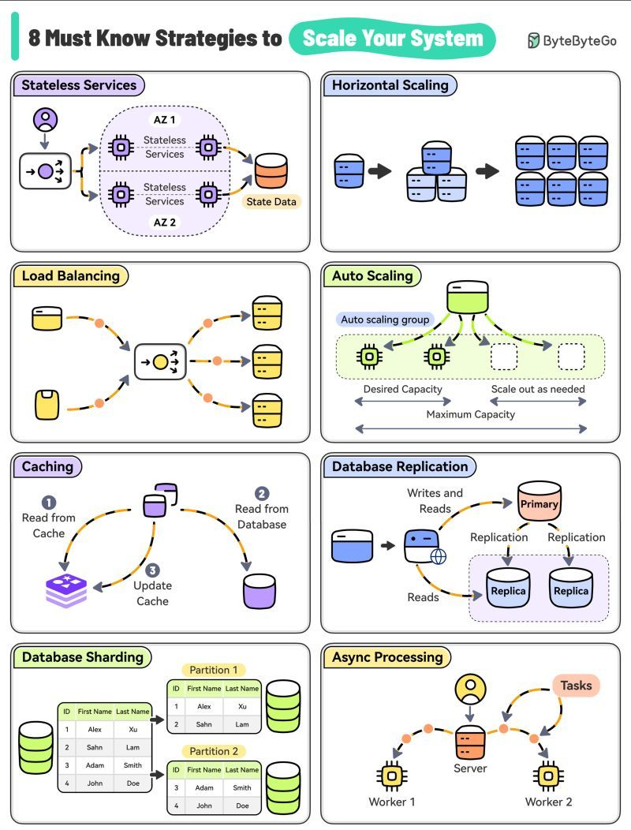

As web applications grow, so must the infrastructure. Let's discuss 8 key strategies to build scalable systems:  
  
🔶 Stateless Services: Enhance flexibility and fault tolerance  
  
🔶 Horizontal Scaling: Add machines to distribute load  
  
🔶 Load Balancing: Efficiently spread traffic across servers  
  
🔶 Auto Scaling: Dynamically adjust resources with demand  
  
🔶 Caching: Boost response times and reduce database strain  
  
🔶 Database Replication: Increase data availability and read speed  
  
🔶 Database Sharding: Partition data for improved write scalability  
  
🔶 Async Processing: Handle time-consuming tasks without blocking  
  
These techniques form the backbone of high-performance, scalable web architectures.

𝐇𝐨𝐰 𝐭𝐨 𝐈𝐦𝐩𝐫𝐨𝐯𝐞 𝐀𝐏𝐈 𝐏𝐞𝐫𝐟𝐨𝐫𝐦𝐚𝐧𝐜𝐞  


Harness the power of peak API performance with these expert strategies designed to supercharge your digital interactions. From smart pagination to seamless asynchronous operations, discover how to elevate your API's efficiency and responsiveness:  
  
 Pagination  
  
- Efficient Data Transfer: Implement server-side pagination.  
- Client Navigation: Use intuitive query parameters like `page` and `pageSize`.  
- Clear Documentation: Provide guidance in your API documentation.  
  
 Seamless Asynchronous Logging  
  
- Asynchronous Logging: Log activities asynchronously.  
- Reduce Overhead: Use message queues or dedicated services for background processing.  
  
 Connection Pooling  
  
- Optimized Operations: Employ strategic connection pooling.  
- Stable Management: Ensure swift and stable database interaction.  
  
 Advanced Caching Techniques  
  
- Fast Access: Use in-memory systems like Redis or Memcached.  
- Reduce Strain: Employ HTTP caching directives.  
  
 Dynamic Load Balancing  
  
- Resilient API: Implement intelligent load balancing.  
- Balanced Load: Distribute incoming requests across multiple servers.  
  
 Payload Compression  
  
- Streamlined Transmission: Utilize compression techniques like GZIP, Brotli, or Zstandard.  
- Quick Interactions: Reduce transfer times for efficient API interactions.

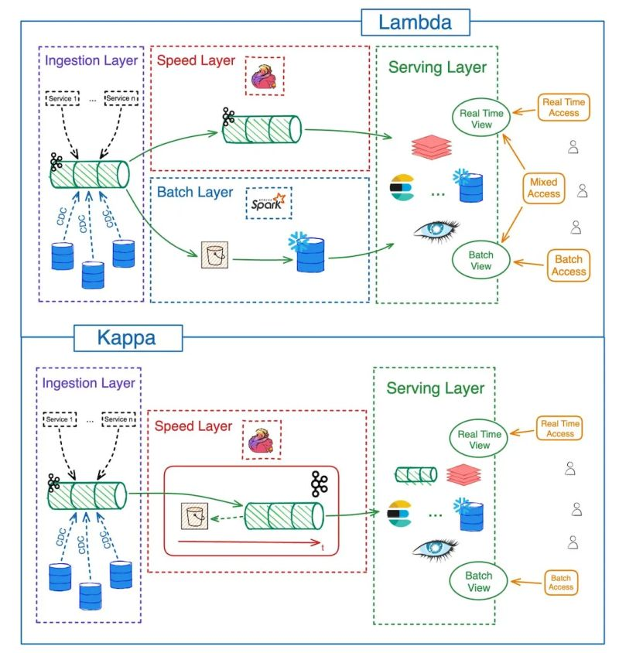

**How to calculate availability of the system?**

**What is Availability?**

Availability is the proportion of time a system is in a functioning condition. It’s a key performance indicator in service level agreements (SLAs) and is crucial for ensuring continuous service delivery. Mathematically, availability is calculated as:

Availability = Uptime / (Uptime + Downtime)

This can also be expressed using MTBF and MTTR:

Availability = MTBF / (MTBF + MTTR)

Where:

* #MTBF (Mean Time Between Failures) is the average time elapsed between two consecutive failures.
* #MTTR (Mean Time to Repair) is the average time taken to repair a system and bring it back to operational status after a failure.

**Mean Time Between Failures (MTBF)**

MTBF is a reliability metric that predicts the time duration between inherent failures of a system during normal operation. It is calculated as:

MTBF = Total Operational Time / Number of Failures

**Example:**

Imagine a server that operates for 600 hours in a month and experiences 3 failures in that time:

* Total Operational Time = 600 hours
* Number of Failures = 3

Calculation: MTBF = 600 hours / 3 failures = 200 hours

This means, on average, the server runs for 200 hours before experiencing a failure.

**Mean Time to Repair (MTTR)**

MTTR measures the average time taken to repair a system and restore it to operational status after a failure. It includes diagnosis, repair, testing, and restoration times. MTTR is calculated as:

MTTR = Total Downtime / Number of Failures

**Example:**

Using the same server example, suppose the total downtime due to the 3 failures is 6 hours:

* Total Downtime = 6 hours
* Number of Failures = 3

Calculation: MTTR = 6 hours / 3 failures = 2 hours

This means, on average, it takes 2 hours to repair the server and bring it back online after a failure.

**Calculating Availability**

Now, let’s calculate the availability using the MTBF and MTTR from the examples above:

* MTBF = 200 hours
* MTTR = 2 hours

Availability = MTBF / (MTBF + MTTR)

Plugging in the values: Availability = 200 hours / (200 hours + 2 hours) = 200 / 202 ≈ 0.9901

This means the server has an availability of approximately 99.01%.

**Optimizing Availability**

To improve availability, you can:

Increase MTBF: Enhance system reliability to reduce failure frequency.

* Example: Regular maintenance, using more reliable components, implementing fault-tolerant designs.

Reduce MTTR: Minimize the repair time through efficient maintenance procedures, better diagnostic tools, and trained personnel.

* Example: Implementing automated failure detection and repair mechanisms.

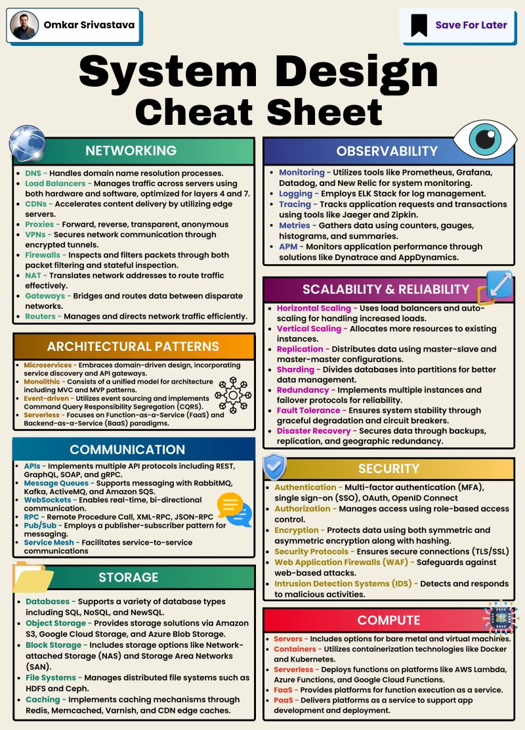

Here’s a detailed breakdown of essential components:  
   
1. Networking: Manages how data is exchanged across networks. It involves DNS for domain name resolution, Load Balancers for traffic management, and CDNs for accelerating,content delivery. VPNs ensure secure communication, and NAT manages IP address   
routing.  
   
2. Observability: Tools like Prometheus, Grafana, and New Relic monitor system operations. Observability is enhanced by logging with ELK Stack, tracing with Jaeger, and metrics collection using various counters and gauges.  
   
3. Scalability & Reliability: Techniques include Horizontal Scaling through load balancers, Vertical Scaling by allocating more resources, and Replication for data distribution. Sharding improves database performance, and Redundancy ensures failover capabilities.  
   
4. Architectural Patterns: Includes Microservices for dynamic, scalable applications and Monolithic architecture for simpler, unified management. Event-driven and Serverless   
architectures respond to events and operations without dedicated servers.  
   
5. Communication: Involves APIs with protocols like REST and GraphQL, message queues with tools like RabbitMQ, and RPC for remote procedure calls. WebSockets support real-time bi-directional communication.  
   
6. Storage: Encompasses Databases that support SQL and NoSQL, Object Storage for managing data as objects, and Block Storage for structured data storage. Caching mechanisms speed up data retrieval.  
   
7. Security: Covers Authentication methods like MFA and OAuth, Encryption for securing data, SSL/TLS for secure transmissions, and Intrusion Detection Systems to monitor and prevent breaches.  
   
8. Compute: Discusses server options including bare metal and virtual machines,   
containerization with Docker, and serverless platforms like AWS Lambda for running code without managing servers.

**Bursty traffic handling**

**Problem statement:**

*Your application experiences sudden spikes in traffic. Describe a strategy to ensure your system can handle this bursty traffic without degrading the user experience.*

**Practical approach:**

Handling bursty traffic requires both a theoretical understanding of architectural principles and practical strategies that are data-driven and scalable. Let’s dive deeper into the practical application of those concepts, using realistic data and metrics to back up the approach.

**1. Auto-Scaling with Data**

Auto-scaling is the backbone of handling spikes, but it requires thoughtful configuration and monitoring. Practical auto-scaling involves setting up triggers based on actual metrics like CPU utilization, request latency, and database load.

* **Example**:
* Current system traffic: **1,000 requests per second (RPS)** during normal hours.
* Expected traffic spike: 10x increase, i.e., **10,000 RPS** within a 10-minute window due to an event like a flash sale.
* **Scaling strategy**:
* Set auto-scaling to trigger when the CPU utilization of web servers exceeds **70%**.
* **Increase instances by 50%** every time the utilization goes above the threshold.
* Use predictive scaling if the event is planned (e.g., a marketing campaign).

**Practical Data:**

* **Instance scaling time**: AWS EC2 instances typically take **2–3 minutes** to spin up. In cases where latency impacts the user experience, you need to ensure scaling occurs fast enough to handle spikes.
* **Over-provisioning**: To avoid scaling delays, you might want to provision **10–20% additional capacity** ahead of time based on traffic trends.

**Approach:**

* Use **historical traffic data** to understand how spikes behave, e.g., spikes due to scheduled events.
* **Example metric**: You observe that your user traffic typically spikes from 1,000 to 8,000 RPS within the first 5 minutes of an event. You can pre-scale your instances to handle this, keeping **idle headroom** of at least 20% capacity.

**2. Load Balancing with Metrics**

Load balancers not only distribute traffic but help ensure the system’s health under extreme load.

**Practical Data:**

* **Traffic balancing capacity**: Assume a load balancer can handle **100,000 requests per second (RPS)**.
* **Latency threshold**: You monitor and observe that as your servers approach **80% capacity**, the request latency increases to **300ms** (from an average of 150ms). This threshold should trigger action.
* **Failure rates**: If the error rate exceeds **5%**, the load balancer can route traffic to healthier instances.

**Approach:**

* **Metric**: Set a **5% error rate threshold** and monitor latency. If traffic spikes cause latency to rise, the load balancer can immediately divert to underutilized servers.
* **Scenario**: If a server group is reaching 80% utilization, a load balancer might offload 10% of traffic to the next group, reducing stress and keeping latency within acceptable limits.

**3. CDN and Cache Hit Rates**

A CDN reduces the load on origin servers by caching static assets like images, CSS, and JavaScript.

**Practical Data:**

* **Cache hit ratio**: Target a **90%+ cache hit ratio** for static content.
* **Example**: If you have 1 million requests during a spike, with a cache hit ratio of 90%, **900,000 requests** will be served by the CDN, significantly reducing the load on your servers.
* **Latency reduction**: Without a CDN, fetching assets might take **500ms** per request. With a CDN, response times drop to **50ms**, vastly improving user experience.

**Approach:**

* Monitor cache performance. If the hit ratio drops below 90%, investigate issues like cache invalidation or lack of proper caching rules.
* **Example**: In a traffic spike from 1,000 RPS to 10,000 RPS, your CDN can handle 9,000 RPS. This leaves only 1,000 RPS hitting your origin servers, avoiding overload.

**4. Rate Limiting in Numbers**

Rate limiting helps ensure that a few users don’t hog resources, making the system resilient under load.

**Practical Data:**

* **Limit strategy**: Set a limit of **100 requests per user per minute**. Any user exceeding this gets **throttled**.
* **Impact on system**: By enforcing this, if a user’s requests spike due to an issue (e.g., bot attack or misbehaving client), it prevents the system from becoming overwhelmed.
* **Real-world use case**: During a DDoS attack, rate limiting can block millions of harmful requests and protect critical resources. In normal conditions, it helps throttle users who send too many requests.

**Approach:**

* Use a **token bucket** or **leaky bucket** algorithm to allow brief bursts, but still enforce an upper limit.
* **Example**: If you have **500,000 users** online, and each is limited to 100 requests per minute, the system will handle **50 million requests per minute**. Exceeding this triggers throttling mechanisms.

**5. Message Queue Depth and Metrics**

Queues like **Kafka** or **RabbitMQ** help you manage bursty workloads by decoupling tasks that don’t need to be processed in real time.

**Practical Data:**

* **Queue depth monitoring**: Monitor the number of unprocessed messages (queue depth). If the depth exceeds a threshold (e.g., **5,000 messages** waiting), you need to scale your consumers.
* **Processing rate**: If your system can handle **500 messages per second**, a spike of 10,000 messages within a minute will saturate the system unless more consumers are added to handle the load.

**Approach:**

* Scale message consumers dynamically. If you expect traffic spikes, provision **20% more consumers** during peak periods to ensure real-time processing doesn’t degrade.
* **Example metric**: During traffic spikes, if queue depth consistently stays above 10,000 messages, automatically spin up more consumer instances to reduce backlog.

**6. Predictive Scaling Based on Historical Data**

If you have predictable traffic patterns (e.g., e-commerce sales, seasonal spikes), **predictive scaling** uses historical data to provision resources before spikes happen.

**Practical Data:**

* **Historical patterns**: If you observe that traffic spikes from 1,000 RPS to 20,000 RPS during specific sales events, set up auto-scaling policies based on this data.
* **Scaling thresholds**: Scale up when CPU utilization exceeds **60%**, but also consider **pre-scaling** 15 minutes before expected traffic peaks based on previous trends.

**Approach:**

* Use data to predict traffic peaks and scale infrastructure in advance. This avoids the delays that come with reactive scaling, which could result in poor user experience.
* **Example**: During a Black Friday event, based on last year’s data, you expect 100,000 RPS at 9 AM. Pre-scale your infrastructure to handle 120,000 RPS at 8:45 AM to ensure a smooth experience.

**7. Monitoring and Proactive Alerts**

Monitoring helps you track resource usage and performance metrics during traffic spikes, allowing you to proactively prevent issues.

**Practical Data:**

* **Threshold metrics**:
* **CPU utilization**: Alert at **80%**.
* **Database connection pool saturation**: Alert when **85%** of available connections are in use.
* **Error rates**: Set an alert when **5%** of requests result in errors.

**Approach:**

* Use **Datadog, Prometheus**, or **New Relic** to track critical performance metrics and set up alerts. When thresholds are hit, automatic actions like scaling or throttling can be triggered.
* **Real-world example**: You notice that during a sudden spike, database connections are saturated. A proactive alert allows you to increase the connection pool size or scale your database layer before failures occur.

**Conclusion (with Data-driven Strategy)**

Handling bursty traffic is all about **proactive capacity planning** and **real-time system optimization**. You need to monitor key metrics, such as CPU usage, request latency, cache hit ratio, and queue depths, to ensure your system scales smoothly and handles spikes effectively. In practical terms:

* **Auto-scaling** ensures horizontal scaling in minutes to handle spikes from 1,000 to 10,000 RPS.
* **CDNs and caching** take 90% of the load off your servers, improving response times from 500ms to 50ms.
* **Rate limiting** prevents any individual user from abusing system resources.
* **Message queues** buffer high traffic and allow you to process 10,000+ messages without overloading services.
* **Predictive scaling** and monitoring help you stay ahead of predictable traffic patterns, minimizing delays and downtime.

This practical approach ensures that bursty traffic is absorbed with minimal impact on user experience.

**Theoratical aspects:**

Handling sudden spikes in traffic requires a combination of **scalability**, **resiliency**, and **performance optimization** to ensure that your system can absorb bursty traffic without degrading the user experience. Below is a strategy to effectively manage traffic spikes, along with architectural patterns to ensure smooth handling.

**Key Strategies to Handle Traffic Spikes**

**1. Auto-Scaling**

* **Dynamic Auto-Scaling**: Use cloud-based auto-scaling services (e.g., AWS Auto Scaling, Google Cloud’s Managed Instance Groups) to automatically adjust the number of servers or containers based on real-time traffic.
* **Horizontal Scaling**: Scale out by adding more servers to handle additional load during peak traffic and scale back in when the traffic subsides.
* **Vertical Scaling**: If certain components can’t be horizontally scaled (like databases), ensure that vertical scaling (increasing server capacity) is possible during spikes.

**2. Load Balancing**

* **Global Load Balancing**: Use load balancers to distribute incoming traffic across multiple instances or data centers. Load balancers can:
* **Distribute Traffic Evenly**: Ensure that no single server is overwhelmed by a traffic spike.
* **Geo-Distribution**: Direct users to the nearest server geographically, reducing latency and improving the user experience during high load.
* **Health Checks**: The load balancer should automatically detect unhealthy instances and stop sending traffic to them, ensuring only healthy servers handle requests.

**3. Caching Layers**

* **Content Delivery Network (CDN)**: Use a CDN (e.g., Cloudflare, Akamai) to cache static assets (e.g., images, CSS, JS) closer to the users. This reduces load on origin servers by offloading traffic to edge locations.
* **Database Caching**: Use in-memory caching systems like **Redis** or **Memcached** to cache frequently accessed data (e.g., user profiles, session data) and reduce the load on your database.
* **Cache-aside Pattern**: Ensure the application checks the cache first before querying the database. If the data is not found, fetch it from the database and store it in the cache for future requests.

**4. Rate Limiting and Throttling**

* **Rate Limiting**: Implement rate limiting to control the number of requests a user or client can make within a given time frame. This prevents any single user from overwhelming the system.
* Use token bucket or leaky bucket algorithms to allow bursts of traffic while enforcing limits over time.
* **Throttling**: Gradually slow down or reject non-essential requests when the system is overloaded, prioritizing critical services and ensuring that essential user interactions remain responsive.

**5. Queue-Based Systems**

* **Message Queuing**: Introduce message queues (e.g., **RabbitMQ**, **Amazon SQS**, **Kafka**) to decouple services. When a traffic spike occurs, instead of directly processing requests synchronously, offload the tasks to a queue where they can be processed asynchronously.
* **Backpressure Handling**: By using message queues, you can handle bursty traffic by allowing the system to process requests at a sustainable rate. Queues smooth out traffic spikes and prevent the system from being overwhelmed.

**6. Circuit Breaker Pattern**

* **Circuit Breakers**: Implement a circuit breaker pattern in your services to prevent cascading failures during spikes. If a service is under heavy load and starting to fail, the circuit breaker can trip, preventing additional requests from overwhelming it.
* **Open State**: The service stops accepting new requests temporarily and returns a predefined fallback response.
* **Half-Open State**: After a cooldown period, the circuit breaker allows a small number of requests to test whether the service has recovered.

**7. Elastic Data Storage**

* **Database Sharding**: Split your database horizontally into shards based on key attributes (e.g., user ID) to distribute the load across multiple databases. Sharding ensures that no single database becomes a bottleneck during traffic spikes.
* **Read Replicas**: Use read replicas to distribute read-heavy traffic during spikes. For example, in AWS, you can use Amazon RDS with multiple read replicas to spread out the read load.
* **NoSQL Databases**: For highly scalable needs, consider using NoSQL databases (e.g., **Cassandra**, **MongoDB**) that can scale horizontally across multiple nodes to handle bursty traffic without a performance hit.

**8. Graceful Degradation and Fallbacks**

* **Feature Flags**: Use feature flags to gracefully disable non-essential features during traffic spikes, ensuring core functionality remains available to users. For example, you could disable high-resource features like real-time notifications or background processes.
* **Fallback Mechanisms**: Implement fallback strategies for essential features. For example, if a third-party service fails during a spike, return cached or default data to users instead of failing completely.

**9. Asynchronous Processing**

* **Event-Driven Architecture**: For non-critical tasks (e.g., sending emails, generating reports), offload processing to background workers. This reduces the real-time load on the main application and allows tasks to be processed asynchronously.
* **Batch Processing**: For tasks that can be delayed, such as analytics or data aggregation, queue them for batch processing during off-peak hours.

**10. Monitoring, Alerts, and Proactive Scaling**

* **Real-Time Monitoring**: Use monitoring tools like **Prometheus**, **Grafana**, or **Datadog** to monitor key metrics (CPU usage, memory, request latency, error rates) in real-time.
* **Alerts**: Set up alerts based on performance thresholds. If traffic spikes or key resources are overwhelmed, send alerts to the operations team for proactive mitigation.
* **Predictive Scaling**: If traffic spikes are predictable (e.g., during promotions, events, or holidays), implement predictive scaling based on historical patterns. Use machine learning models to forecast traffic spikes and scale the infrastructure in advance